Prof Richard Ignace Physics & Astronomy
ignace@etsu.edu East Tennessee State University

Instructions for Lab Report Template

General Physics Lab counts for intensive writing credit; therefore, the quality of your writing will be a significant component of your grade. Lab reports should be clear, concise, and technical. They are to present your data and your conclusions. They should include a stated objective, assumptions, and conclusions. The report should describe the experiment and provide an explanation of the results. The technical report must be coherent and easy to follow.

To assist in the orderly presentation of your report, this template is being provided. The template includes a sample table that you can adjust (or delete) as needed. There is also space for graphs and figures. You might port graphics into the file use that box for carefully hand-drawn figures.

You will receive deductions for shabby work, in the form of poor grammar, repeated typos, or badly drawn figures.

IMPORTANT: You must attach your raw data sheet to your report. You will receive a zero score without the data sheet.

Tips

- If you have multiple tables, label them and cite them properly. For example, “Table A lists our measurements, whereas Table B contains calculated values for ….”
- The location of tables and figures is not rigid but depends on the flow of the report. Consider where those objects should most sensibly appear in the report. For example, avoid having all the tables and figures at the end.
- Technical writing is boring. This is intentional so that a reader can more easily follow the steps of the experiments and the analysis. Avoid colloquialisms, slang, and vague language.
- Use the equation editor if you can; otherwise, leave space to hand write equations.

Richard Ignace
PHYS-0000-000
AB-1
My Summer Health

PURPOSE/OBJECTIVE

This experiment pertains to the use of physical data to evaluate changes in personal health. The influence of a change in behavior on personal health is evaluated. Behavior patterns are assessed through measurements of duration of sleep and food consumption. Body weight is used as a proxy for personal health level.

EXPERIMENTAL APPARATUS

The experiment makes use of a digital clock to determine sleep durations and scales to measure meal portions and to track body weight.

PROCEDURE

a) Sleep Times

I slept a great deal. To find out how much I slept, I used a clock to determine the time at which I laid down and the time at which I woke up. I made careful measurements of the ingress and egress from slumber during the first full week of June. Times are tabulated in Table A. For comparison I normally got about 7 hours of sleep before the summer break.

Table A: Timing Data
Day | Time to Bed  (digital format) | Time to Awake  (digital format) | Slumber Time  (hours)
1 | 12:42:09 am | 10:19:06 am | 9.6158
2 | 01:02:49 am | 12:23:16 pm | 11.3408
3
4
5
6
7

b) Meals and Body Weight

I ate a great deal. In order to determine how much I ate, I weighed all of my food before consuming it. I also kept track of my body weight before going to bed (so at the clock times in column 2 of Table A). Measurements for food masses and body weights appear in Table B.
Table B: Weight Measurments
Day | Mass of Breakfast  (kg) | Mass of Lunch  (kg) | Mass of Supper  (kg) | Body Weight  (lbs)
1 | 1.12 | 0.64 | 0.85 | 156
2 | 0.92 | 1.28 | 1.29 | 158
3
4
5
6
7

For comparison, a typical meal before the summer break had roughly half the mass of meals that I ate during the summer. At the beginning of the summer, I weighed approximately 152 lbs. By the end of the summer, I weighed approximately 170 pounds.

Figure 1 shows a standard height-weight graph indicating healthy and unhealthy areas. My shift in weight bumped from a healthy zone to an unhealthy one.

Figure 1: Height-Weight Graph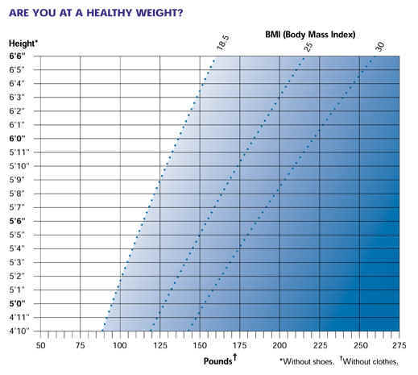

RESULTS

I found that I slept on average about 9.5 hours over the summer, using my tabulated values in June as typical ones. Given that I slept 7.0 hours prior to summer, my sleep increased by

The extra sleep felt good. However, it also represents a reduced level of exercise. Note that the 7.0 hours of average sleep prior to the summer is an estimate only. The error in that value is probably +/- 30 minutes, or half an hour. The relative error is thus 0.5/7 = 0.07. So a better representation of the increase in my sleep is 36% +/- 3%.

At the beginning of the summer, I weighed about 152 lbs. By the end of the summer, weighing 170 lbs, my weight changed by approximately

SUMMARY/CONCLUSIONS

Even though I ate approximately double the amount of food in the summer as compared to prior, and even though I slept nearly one third longer, my weight only increased by little more than 10%. I find this surprising and have no explanation. Perhaps this is related to metabolism. It would be interesting to try this experiment with different people who have different metabolisms. Certainly, it is clear that reduced activity (as symbolized by sleeping longer) and larger meal portions led to an increase in body weight. This increase is interpreted as a decrease in personal health based on the information of Figure 1.

