WSJ Quotes

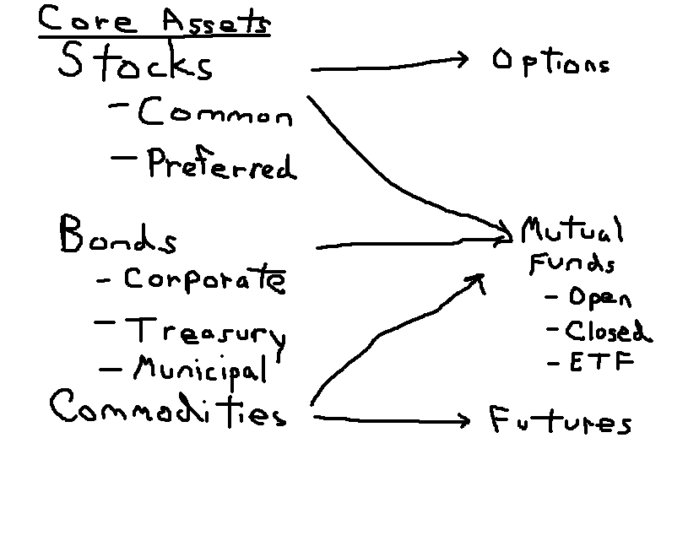

As an introduction to investments, this overview takes us through all the financial assets we will look at this semester. There is a great deal of information here, but I feel it is important that everyone should be able to tell me what these assets are, and how to interpret the quotes that a myriad of financial sites give us.

General Stock Information – Trivial Pursuit Type Information

1) DJIA is the Dow Jones Industrial Index which is composed of 30 large industrial stocks. It is a price weighted index and involves adding up the prices of the stocks and dividing by a denominator. There is also a Dow Jones Transportation Index(20 stocks) and a Utilities Index(15 stocks).
2) The New York Stock Exchange is an actual trading floor located on Wall Street although recently it has gone almost all electronic. There is also the American Stock Exchange, also in New York, the Nasdaq Exchange(computer network), and 5 regional exchanges, the large regional ones being the Pacific in San Francisco, and the Chicago and Boston exchanges.
3) The CBOE, Chicago Board Options Exchange trades options while the CME, Chicago Mercantile Exchange and CBT, Chicago Board of Trade deal mainly with future contracts.
4) There are approximately 3000 companies on the NYSE worth approximately 16 trillion.
5) The S&P 500 is a broader index covering the 500 largest companies in the U.S., it is a value weighted index. The NASDAQ which comes from the National Association of Security Dealers Automated Quotation system is primarily for smaller companies although MSOFT among other large stocks are listed on the Nasdaq. It is laden with tech companies at the moment.

1. Stock Quotes:
Let’s say you had $1,000 back in 1990. You gave it to a couple from Stanford who liked to connect their computer labs together who had started a company 6 years earlier. By March of 2000, you would have been worth over a $1,000,000! The tech crash was rather painful for you since you lost $900,000, but by Jan. 2007, you would be back up to over $250,000. Interested???? Stocks can be exciting, just ask some of the millionaire groundskeepers and secretaries at Microsoft who took their Christmas bonuses in the form of stock.

To attain an idea of how the overall market is doing, stock indexes are the most widely quoted benchmark.

Uses of Stock Indexes

Track average returns

Comparing performance of managers

Base of derivatives

Factors for Construction of Stock Indexes

Representative?

Broad or narrow?

How is it weighted?

Examples of Indexes - Domestic

Dow Jones Industrial Average (30 Stocks)
Here are some of the recent changes.
- On 17 March 1997, Hewlett-Packard, Johnson & Johnson, Travelers Group, and Wal-Mart joined the average, replacing Bethlehem Steel, Texaco, Westinghouse Electric and Woolworth.
- In 1998, Travelers Group merged with CitiBank, and the new entity, CitiGroup, replaced the Travelers Group.
- On 1 November 1999, Home Depot, Intel, Microsoft, and SBC Communications joined the average, replacing Union Carbide, Goodyear Tire & Rubber, Sears, and Chevron.
- Between 1999 and 2004, several stocks in the index merged and/or changed names: Exxon became Exxon-Mobil after their merger; Allied-Signal merged with Honeywell and kept the Honeywell name; JP Morgan became JP Morgan Chase after their merger; Minnesota Mining and Manufacturing offically became 3M Corp; and Philip Morris renamed itself Altria.
- On 8 April 2004, American International Group, Pfizer, and Verizon joined the average, replacing AT&T, Eastman Kodak, and International Paper.
Components of the Dow, July, 2008
Symbol | Name
AA | ALCOA INC
AIG | AMER INTL GROUP INC
AXP | AMER EXPRESS INC
BA | BOEING CO
BAC | BK OF AMERICA CP
C | CITIGROUP INC
CAT | CATERPILLAR INC
CVX | CHEVRON CORP
DD | DU PONT E I DE NEM
DIS | WALT DISNEY-DISNEY C
GE | GEN ELECTRIC CO
GM | GEN MOTORS
HD | HOME DEPOT INC
HPQ | HEWLETT PACKARD CO
IBM | INTL BUSINESS MACH
INTC | INTEL CP
JNJ | JOHNSON AND JOHNS DC
JPM | JP MORGAN CHASE CO
KO | COCA COLA CO THE
MCD | MCDONALDS CP
MMM | 3M COMPANY
MRK | MERCK CO INC
MSFT | MICROSOFT CP
PFE | PFIZER INC
PG | PROCTER GAMBLE CO
T | AT&T INC.
UTX | UNITED TECH
VZ | VERIZON COMMUN
WMT | WAL MART STORES
XOM | EXXON MOBIL CP

Standard & Poor’s 500 Composite
Here’s a nice article when the S&P turned 50.

Many Happy Returns
By JEREMY J. SIEGEL and JEREMY SCHWARTZ
March 1, 2007; Page A12, WSJ
Markets go up, and as Tuesday's dizzying 416-point drop in the Dow reminds us, they go down too, sometimes in a big hurry. Still, we shouldn't let this week's jitters pass without noting that today is the 50th birthday of one of the world's most famous benchmarks for stock-market returns, the S&P 500. Standard and Poor's, the originators and keepers of the index, estimates that over $1 trillion is directly or indirectly tied to the performance of these 500 firms, selected to represent America's economy.
From its inception on March 1, 1957, through the end of last year, the average annual return of the S&P 500 Index, which today comprises almost 80% of the value of all U.S. stocks, has been 10.83%, a return that most active equity managers have found very difficult to match. The changing composition of the index also mirrors larger changes in the economic landscape. Because of mergers, bankruptcies and other corporate changes, almost 1,000 new companies have been added to the index, as others were dropped, since its inception.
In 1957 the technology, health-care, and financial sectors, which today comprise almost one-half the index's value, made up a mere 6% of the index. The financial sector was particularly small in the 1950s and 1960s since commercial and investment banks, as well as brokerage houses, were not included in the S&P 500 until the 1970s.
The biggest industrial sector in 1957 was "materials" -- steel, aluminum, chemical, paper and mining companies. The materials and energy sectors made up half the value of the S&P 500 when the index was originated, compared to only 12% today. Still, the stocks in the original index were winners. By far and away the best performing is Altria Corporation, formerly known as Phillip Morris Corp. From March 1957 through December 2006, this cigarette manufacturer, which in 1980 diversified into foods, gave investors a 19.88% annual return, almost double the annual return of the S&P 500 Index. An investment of $1,000 put into Philip Morris in 1957 would have grown to $8.4 million by the end of 2006 -- compared to a mere $168,000 accumulation in the S&P 500 itself.
Surprisingly, the second best performing stock of the original 500 was Thatcher Glass Co., a profitable milk bottle manufacturer in the early 1950s. When the baby boom turned into a baby bust and glass milk bottles were replaced by waxed cartons, Thatcher Glass was bought by Rexall Drug, which became Dart Industries, which merged with Kraft, and was eventually bought by Philip Morris in 1988. A $1,000 investment in the dominant manufacturer of an obsolete product turned into a $4.95 million bonanza for investors.
Other stocks in the 1957 index paid off big. Of the 111 original companies that have survived intact, 20 outperformed the index by an average of almost five percentage points per year. These include PepsiCo, Coca-Cola, Colgate Palmolive, Heinz, Wrigley, Procter & Gamble, Hershey and Tootsie Roll Industries. The pharmaceutical industry performed brilliantly for investors, as Abbott Labs returned nearly 16% per year, while Merck, Bristol Myers Squibb, Pfizer and Schering Plough, despite their recent troubles, all handily beat the S&P 500 Index.
The firms that dominated the original list did very well for their investors. AT&T was the largest stock in the index in 1957 with market capitalization of $11.2 billion (that capitalization would rank in the bottom 200 of today's S&P 500 firms). The telephone monopoly known as "Ma Bell" was broken up in 1984, giving birth to the "Baby Bell" regional providers. AT&T was bought by one of its children, SBC Communications in 2005 and, through other acquisitions, worked itself back to the top 20 in market value. The 50-year return on AT&T, had you also held all the Baby Bells when Ma Bell spun them off 23 year ago, gave you a 10.77% annual return, virtually matching the index.
Another perspective: 12 of the 20 largest companies in the original 1957 index beat the performance of the index; and a portfolio of all 20 bested the index by almost one percentage point per year. The winners among these original stocks include all the oil companies (Mobil, Royal Dutch, Exxon, Shell, Amoco, Gulf, Chevron, Phillips and Texaco), as well as General Electric, IBM and Sears (thanks to Eddie Lampert and Sears Holdings). Union Carbide, Du Pont, Eastman Kodak, Alcoa, General Motors and U.S. Steel lagged the index but only one stock -- Bethlehem Steel -- lost all of its investors' money.
Surprisingly, if an investor had bought a portfolio of all 500 companies that Standard and Poor's placed in the index on March 1957 and held them until today, he would have not only handily beat the S&P 500 Index itself; he would have outperformed most money managers that have tried to beat it. This is truly remarkable -- given that such an investor would have never purchased a single one of the nearly 1,000 new companies that were added to this famous index over the past half century.
Happy Birthday, S&P 500. You have certainly aged well.
Mr. Siegel is professor of finance at the Wharton School and author of "The Future for Investors" (Crown, 2005). Mr. Schwartz is deputy director of research at WisdomTree Investments.
Interesting test questions from article might be: 1) What % of the value of all U.S. Stocks is composed within the S&P 500? 2) What was the best performing company from the original 500? 3) Approximately How many new companies have been added over the last 50 years?

NASDAQ Composite

NYSE Composite

Wilshire 5000

Examples of Indexes - Int’l

Nikkei 225 & Nikkei 300

FTSE (Financial Times of London)

Dax

Region and Country Indexes

EAFE

Far East

United Kingdom

Construction of Indexes

How are stocks weighted?

Price weighted (DJIA)

Market-value weighted (S&P500, NASDAQ)

Example:

Stock | No. shares | P(t=1) | P(t=2) | P(t=3)
A | 100 | 10 | 12 | 15
B | 50 | 5 | 8 | 7
C | 20 | 20 | 22 | 20

Price weighted, simply add up prices and divide by number of stock. DJIA for example.
Ex. 35/3=11.66 42/3=14 42/3=14

Value weighted, take total market value of stocks each time period, divide by market value time period before and multiply by the index number the previous period.

S&P 500 for example.
(Must start index at some number to begin, let’s use10 for example) 10*(2040/1650)=12.36 which is index value at time period 2, time period 3 the value weighted index number would be 12.36 * 2250/2040 = 13.64.

Individual Stock Quotes
Stocks, often referred to as common equity is a residual claim asset, it has limited liability. You can only lose the amount you buy.
See below for quote. You should know the following terms:
Last = last trading price. NYSE is open from 9:30 to 4 p.m. It is the last price traded that day.
Change = change from the preceding day’s close.
Market Cap = total number of shares outstanding multiplied by the stock price
PE ratio = Price divided by most recent last 4 quarters earnings. It is how much you pay for every $1 the company earns.
PEG ratio = PE divided by growth rate. A value under 1 is often considered an indicator that the stock is undervalued while a value over 1 is thought to indicate that the stock is overvalued. The rule by itself has not been of great use for profitable trading but is one of many.
Dividend Yield = Dividend/Closing Price for that day.
Short Interest = number of shares sold short.
Short Interest ratio = number of shares sold short divided by the average volume over the preceding month. Basically tells you how long it would take to cover short sells.
Stock split = 100% is a 2 for 1 stock split meaning the company gave you two shares for every one you had. 200% would be a tripling of the number of outstanding shares while 50% for example would be a 1 for 2 split. Often called a reverse stock split meaning that you now only have 1 share for every two that you had.
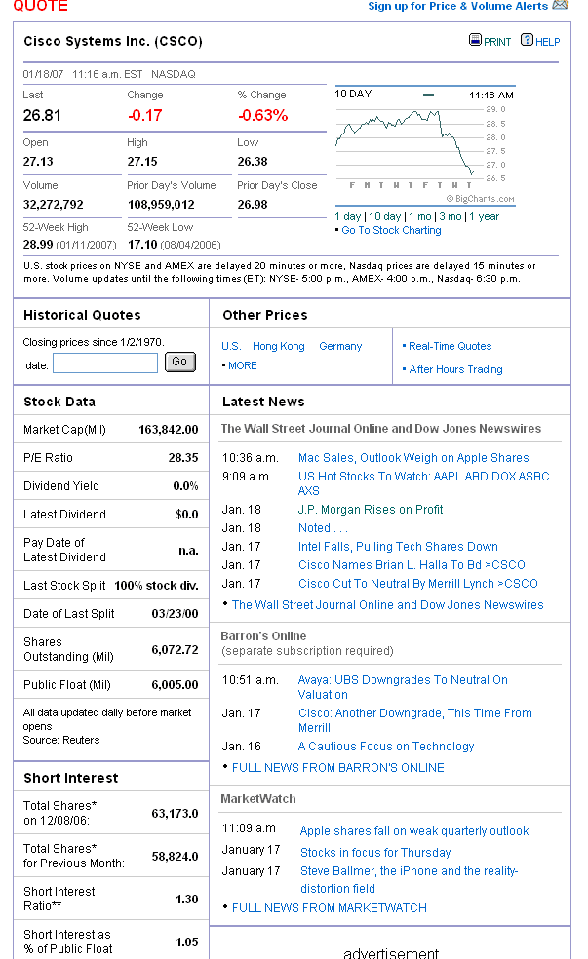

* In thousands
**number of days of average daily volume to close out total short positions.

• Component of S&P 500 Index
Dow Jones Industry Group Center Telecommunications Equipment
Ratings & Estimates
2.1 Mean Recommendation
(1 = Strong Buy,
5 = Strong Sell)
$0.31 Earning Consensus

Date of info. below is May 2007.

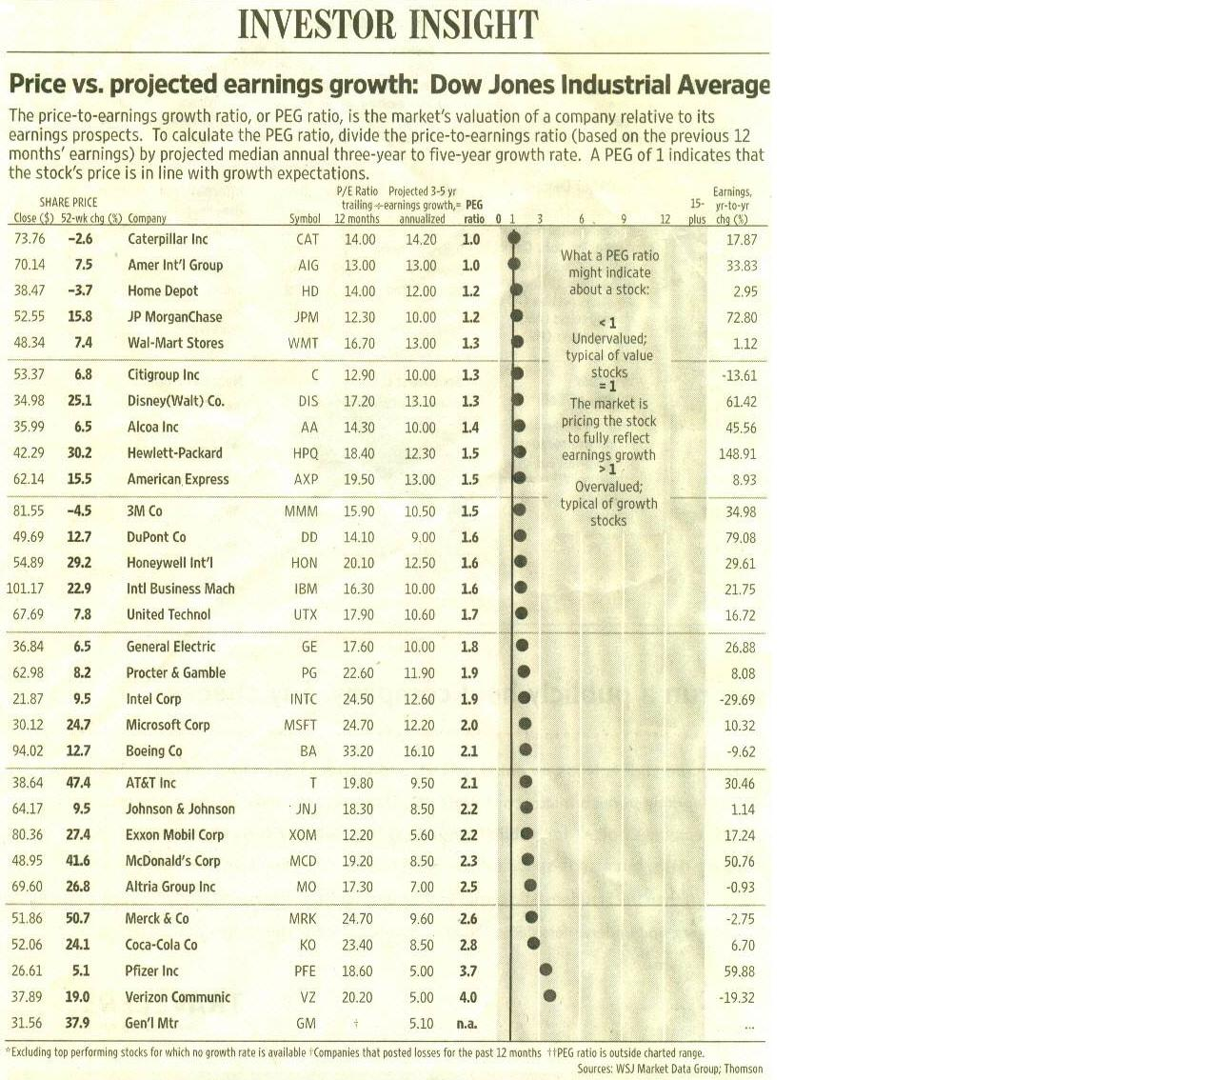

You should know/learn how to interpret the ratios below. The two that are not self-describe are the current ratio which is current assets/current liabilities and the Quick ratio which is (current assets – inventory)/current liabilities. A value greater than 1 basically means that they have enough liquid assets to meet their Current liabilities.
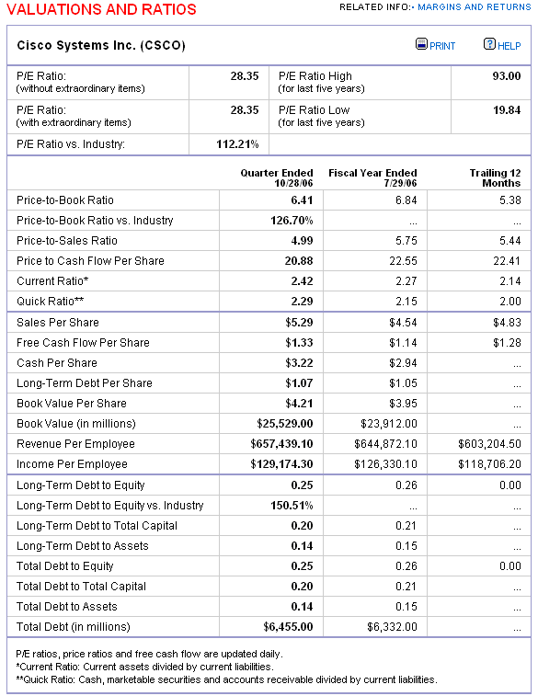

Quote, Home Depot, from Money Central

 | CSCO Intraday Chart  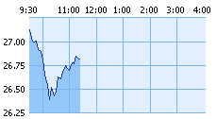  5d 1m 3m 1y 3y 5y 10y
  26.81 -0.17 -0.63%
  Previous Close | 26.98 | Bid | 26.80
  Open | 27.13 | Bid Size | 5,000
  High | 27.15 | Ask | 26.80
  Low | 26.38 | Ask Size | 1,100
  Volume | 34.53 Mil | 52 Week Range | 17.10-28.99
  Market Cap. | 162.81 Bil
  Total Shares Out. | 6.07 Bil
  Avg. Daily Volume | 52.08 Mil
  P/E | 28.40
  Forward P/E | 22.80
  Earnings/Share | 0.95
  Return on Equity | 25.24
  Current Dividend Yield | NA

CSCO, from finance.yahoo.

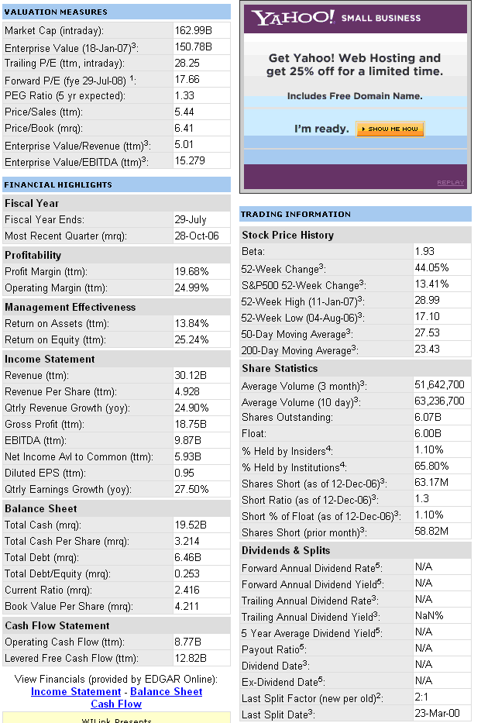

Enterprise value which you can see above in “valuation measures” is becoming a more popular valuation statistic. Although it is calculated in several ways, a standard definition is Market Cap + Debt + Preferred Stock – Cash. Below is an interesting article from the WSJ on the topic.

Click here for article

2. How to read the Stock Ticker
The stock ticker is that scrolling numbered and lettered tape often found at the bottom of financial shows. For instance, you might see the following:
MSFT_{5k} @ 50.50 ⇓ 0.2
This means that the last bid for Microsoft was for 5,000 shares at $50.50, down $.20 from the previous day. Abbreviations that you will see are
K = 1,000
M = 1,000,000
B = 1,000,000,000
Color codes are used as well.
Green: Stock is trading higher than recent close
Red: Stock is trading lower than recent close.
Blue or White: Stock is unchanged from most recent close.
Not every trade is put up on the ticker, factors such as volume, price change, activity, and how widely held the stock is determines whether the trade will be put up on the ticker.

- Purchasing stock
There are 5 main types of orders
1) market order, executed immediately.
2) limit buy or limit sell, limit buy for example is buy when stock falls below some price, limit sell, sell when price goes above some price.
3) day orders, good for the day.
4) open orders, good until canceled.
5) stop-loss orders or stop-sell, sell when price falls below some price. Order is executed regardless of price once price barrier has been reached. For example, stock is at 40 and you place a stop loss order at 35. If price falls to 35, your order becomes a market order and could be sold at 30 if that is the next transaction price.
6) You can also combine orders such as a Sell Stop Limit order. Same example as above but you place a stop price at 35 and a limit price of 33. Thus if stock price falls to 35, your order will be executed only if stock price stays above 33.
7)There are also stop-buy orders to cover short sales which are executed to buy stock if stock price rises past a particular price.

When Protecting an Investment Raises Risks
By KAREN BLUMENTHAL
June 18, 2008; Page D1
This year's volatile stock market is driving investors to a trading technique designed to trim their losses. Yet it can also backfire on those who are in the market for the long term.
PROS AND CONS OF STOP-LOSSES

Investors are increasingly using stop-loss orders to limit downside risk. Here are some pros and cons:
Good test question here.
• Pros: They take the emotion out of a sell decision, limit losses on short-term trades, and can be an effective option for locking in profits.
• Cons: They fail to take into account regular market volatility, and can cause investors to buy stocks at a high price and sell at a low one.
The practice -- known as a "stop-loss order" -- calls for an individual stock to be automatically sold when its share price falls by a certain percentage or hits a designated price. In theory, at least, automatically dumping a holding when it sinks takes the emotion out of the stock-trading decision and spares investors from even greater suffering when the market drops precipitously, as it did when it fell nearly 400 points on June 6.
For buy-and-hold investors, however, what seems like a conservative strategy can actually boomerang. Consider what happened to the Stockbusters investment club, a group of about 25 Dallas women that has been meeting and picking stocks together for two decades. Earlier this year, the club members studied and then agreed to buy two energy company stocks, XTO Energy Inc. and Chesapeake Energy Corp.
Though the club invests for the long term, the members put in a stop-loss order calling for the shares to be automatically sold if the prices dropped by 10%. Before the next monthly meeting, both stocks had been sold. Both then rebounded within weeks and continued to gain. "That didn't go well," says Nanci Roberts, the club's treasurer.
To avoid missing out on future gains on their Apple Inc. stock, the club members decided to not to use a stop-loss order after having to buy shares back several times after stop-loss triggers.
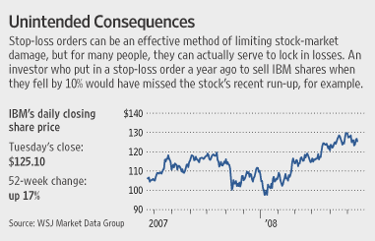
Such is the challenge investors face in trying to outsmart the stock market. They have a quiver full of tools, but one may work beautifully for one investor and disastrously for another, depending on each one's approach and goals. Stop-loss orders are clearly double-edged, working well for the quick-hit trader and those who follow market trends, but poorly for those who are looking for long-term value in their investments.
Brokerage firms like Charles Schwab Corp., TD Ameritrade Holding Corp. and E*Trade Financial Corp. say they've seen an increase in the use of such risk-management tools as the stock market has become rockier and investors have sought more sophisticated strategies for dealing with it. E*Trade said it has seen the use of stop-losses grow 10% in the past year, while TD Ameritrade says it has also seen double-digit percentage growth.
Placing a stop-loss order is easy: An investor trading online need only add a few clicks to set a price where the stock will be automatically sold or set up a "trailing" stop-loss order to sell if the stock drops a certain amount from a recent high.
For those investors considering whether to execute a stop-loss, here are some rules to consider:
Know thyself. "Stop-loss has a time and place, but it has to be consistent with your overall strategy," says Michael Mauboussin, chief investment strategist for Legg Mason Capital Management.
Momentum traders, or those who study a stock's direction to see if it's on the way up or heading down, tend to move in and out of a stock in a matter of days or maybe weeks. If a stock is falling, it may not be worth hanging on to. These trend-watching traders may ditch a stock if it slips as little as 4% or 6%.
By contrast, long-term investors who study a company's potential earnings and growth prospects looking for bargains should expect some ups and downs in order to reap gains over a couple of years. Assuming nothing else has changed, a stock that looks like a good buy at $30 should be a better buy at $27. For that reason, value investors should consider buying more shares when a stock price falls, and selling when the fundamental story -- not a number -- shifts.
In fact, for these investors, an automatic order to sell if a stock price drops by up to 10% may almost guarantee that they'll buy high and sell low. Individual stocks can swing wildly in price over a year's time, particularly if they aren't actively traded. Even for big stocks, a 10% drop is hardly a big deal these days: Each of the 30 stocks in the Dow Jones Industrial Average has dropped at least that much from its peak in the past year. Indeed, all but seven of the Dow stocks have plunged at least 20% from their top price, though many then rebounded.
Because of the way they work, stop-loss orders don't always guarantee that you won't take a bigger beating. Once your "stop" price is hit, your stock will be sold at whatever the prevailing market price is, even if it's well below your intended sales price -- which happens when a stock is in a price free fall like the one Bear Stearns Cos. rode in mid-March. In such cases, a stock can trade at $12 one minute and $8 the next, bypassing a $10 stop-loss order.
Reduce losses instead of trying to "stop" them. Jeremy Siegel, finance professor at the University of Pennsylvania's Wharton School and a best-selling author, thinks long-term investors should avoid stop-losses altogether. Instead, he recommends a different tack for those worried about a short-term move: buying a "put," or an option to sell the stock at a certain price on a certain date.
A put option covering 100 shares will cost just a fraction of your stock investment, plus a commission, and it can act as a buffer against quick price swings. If the stock price actually falls, the put will rise in value and trim your losses, tempering the pain of a downturn. If the price climbs, you will have given up some profit as insurance against a short-term loss.
Retain your gains. For buy-and-hold investors, a stop-loss order may be most effective for locking in profits rather than stemming losses. Stockholders should have an exit plan for the upside as well as the downside, says Joseph Vietri, vice president of active trading and investing at Charles Schwab. If your Microsoft Corp. shares have jumped to $35 from $24, say, but you're reluctant to part with them yet, a stop-loss order set at $32 would lock in your gains. If the stock falls further and you still believe in its potential, you can always buy the shares again.
- Margin
Buying on margin simple means you borrow money to purchase more stock than you otherwise could.
There are initial margins set be Federal Reserve, currently at 50% and maintenance margins set by brokers, currently at 30%.
Initial margin= investor equity/market value of securities
Maintenance margin = investor equity/market value of securities.
The margin call price is P=L/[N(1-M)] where M is the maintenance margin, N = the number of shares and L is the loan amount. This is the price to which your stock can fall before the broker will call you and either ask you to put up more money or force you to sell some stock. These are the only two ways you can meet a margin call.
Why use margin, because it increases your leverage and levers up your ROE(return on equity).
ROA(return on assets) is income/total investment. ROE on the other hand is (income-interest cost)/equity and since part of income is derived from returns on borrowed funds, return on
equity is levered up.

Examples:
1) Assume you buy $40,000 of Intel at $20 a share using 60% margin. The borrowing rate is 8%, if after one year Intel is at $16 a share, what was your ROA and ROE?

Total Assets = $40,000
Your equity is .6 * $40,000 = $24,000.
You then must have borrowed $16,000.
Your interest cost over the year is then $16,000 * .08 = $1,280.

You bought $40,000/20 = 2000 shares.
Your return then is $16 - 20 * 2000 shares or -$8,000. Always subtract the ending price from the beginning price to determine how much you made or lost.

ROA = Return/Total Assets
ROA = -$8,000/$40,000 = -20%
ROE = (Return - interest expense)/Equity
ROE = (-$8,000 - $1,280)/$24,000 = -38.67%.

Note that the ROE will always in absolute value terms be at least as large as the ROA. ROA and ROE are equal when you use 100% margin, i.e. you do not borrow.

If you do buy stock on margin, note that to breakeven on the funds you borrow, the stock needs to increase by at least the amount of the interest rate. In the example above, the stock needed to increase 8% over the year for you to breakeven on the loan. If the stock does not increase by the amount of the interest rate, you would have been better off by not borrowing at all. Obviously if the stock declines, you will be even worse off.

2) Assume you have $5,000 in equity and you buy 1,000 shares of Apple at $8 a share. The interest rate is 7%. If after 6 months Apple goes to $9.50 a share what is your ROA, ROE, and Initial Margin?

Margin = Equity/Assets = $5,000/$8,000 = 62.5%
Return = 1,000 shares * 1.50 = $1,500.
Interest Expense = $3,000 * .035(only 6 months interest) = $105.
ROA = $1,500/$8,000 = 18.75%
ROE = ($1,500 - $105)/$5,000 = 27.9%.

5.. Short Sales
Short sales involve selling someone's shares at t=0 in the hopes of buying them back at a later date at a lesser price and returning the shares to the original owner. In general, when you short sale a stock, you have to put up an additional amount usually equal to 50% of the short sale amount. This requirement is to ensure that you will have enough money to buy back the stock and return it in case the price goes up.
Largest Short Interest Ratios
The short interest ratio is the number of days it would take to cover the short interest if trading continued at the average daily volume for the month.
 | JAN 12  Short Int | Avg Dly  Vol-a | Days to  Cover
1 Pre-Paid Lgl Sv | 4,496,837 | 57,624 | 78
2 Superior Ind Int'l | 9,412,633 | 200,335 | 47
3 iShares Russell 1000 Index Fu | 20,538,444 | 459,900 | 45

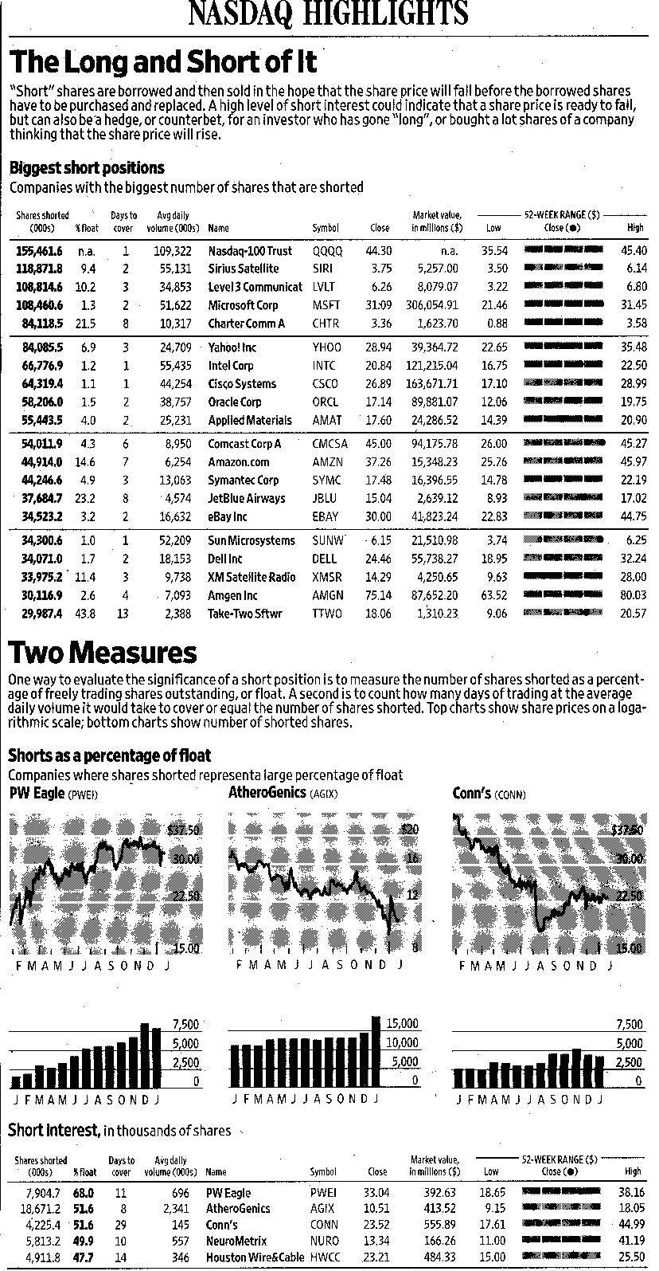

All short sales require the use of margin.
The margin call price for a short sale is P = Total Assets /N(1 + M). Note total assets is value of short plus equity you put up.

Example:
Assume you short sale 1,000 shares of Apple at $8 a share. The interest rate is 5%. If after 6 months Apple goes to $9.50 a share what is your, ROE and Initial Margin?
Margin = $4000
Return = -$1,500, in general, you will not receive interest on margin and from short sale and sometimes have to pay to borrow.
ROE = -$1,500/$4,000.
The margin call price in the above example is P = $12,000/1,000*(1+.3) = $9.23. That means if Apple increases to $9.23 a share, you will receive a margin call meaning you have to put up more margin or buy the stock back and return it.

6. Preferred Stocks
Yld is simply dividend divided by price. Dividend is only paid if corporation has cash available. Preferred stock holders cannot force corporation into bankruptcy if they do not pay. Corporations like buying preferred stock from other corporations rather than common stock since 80% of preferred dividends are tax free for corporations. Common stock dividends that corporations receive do not enjoy preferred tax treatment.

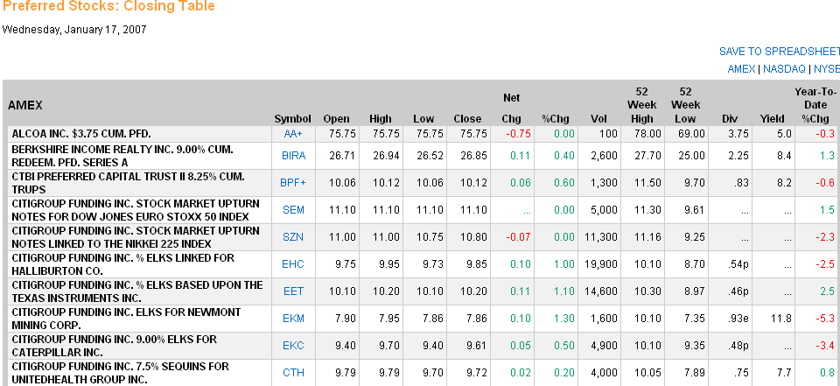

7. IPO’s, Trading

Primary Market

New issue

Key factor: issuer receives the proceeds from the sale

Secondary Market

Existing owner sells to another party

Issuing firm doesn’t receive proceeds and is not directly involved

Third market is trading of securities on the OTC market

Fourth market is direct trading between investors.

Investment Banking Arrangements

Underwritten vs. “Best Efforts”

Underwritten: firm commitment on proceeds to the issuing firm

Best Efforts: no firm commitment

Negotiated vs. Competitive Bid

Negotiated: issuing firm negotiates terms with investment banker

Competitive bid: issuer structures the offering and secures bids

Show Netscape Video

Public Offerings

Public offerings: registered with the SEC and sale is made to the investing public

Initial Public Offerings (IPOs)

Evidence of underpricing (Why?)

Performance

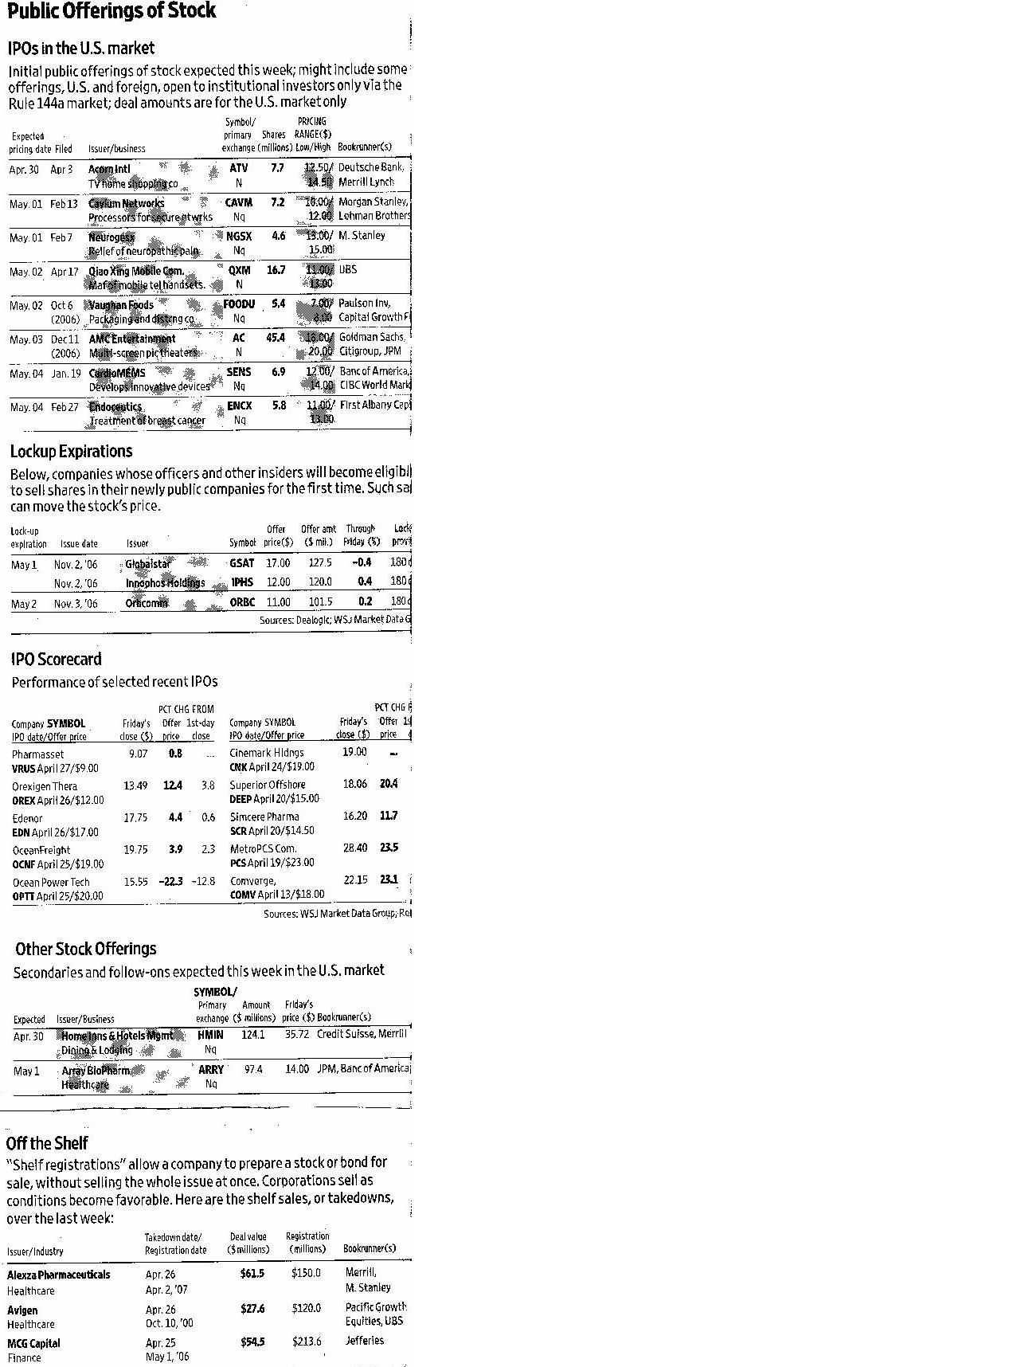

- Corporate Bonds
All bonds mature at par value which is $1000. General obligation bonds are sometimes referred to as debentures. The coupon is how much you receive each year as a % of par. The Morgan Stanley 5.45% coupon means you receive $54.50 a year until it matures, than you will receive $1,000. Its closing price was $987.44.
Bond ratings go from AAA(Best credit) to CCC. If the rating is D, then it is considered in default. BBB or better is considered investment grade, 0.5% or less chance of default. BB and below, historically default rate is around 4% but has reached above 10% in 90-91, 2001 for example.

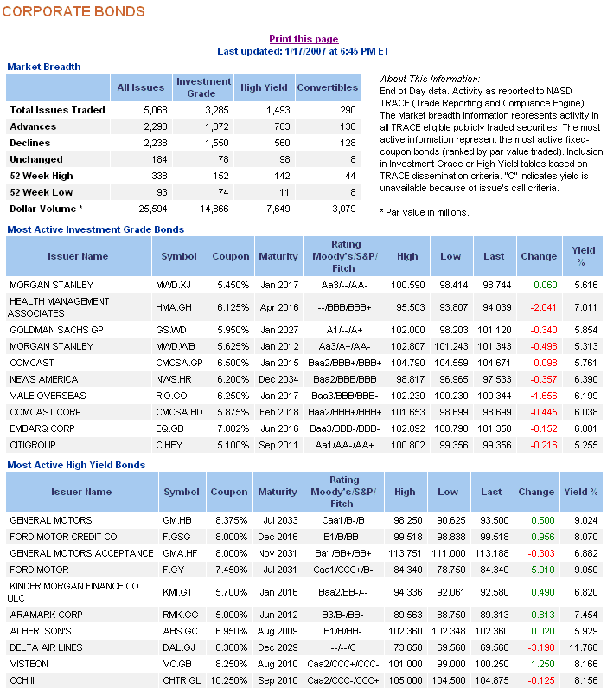

9. Treasury Bonds
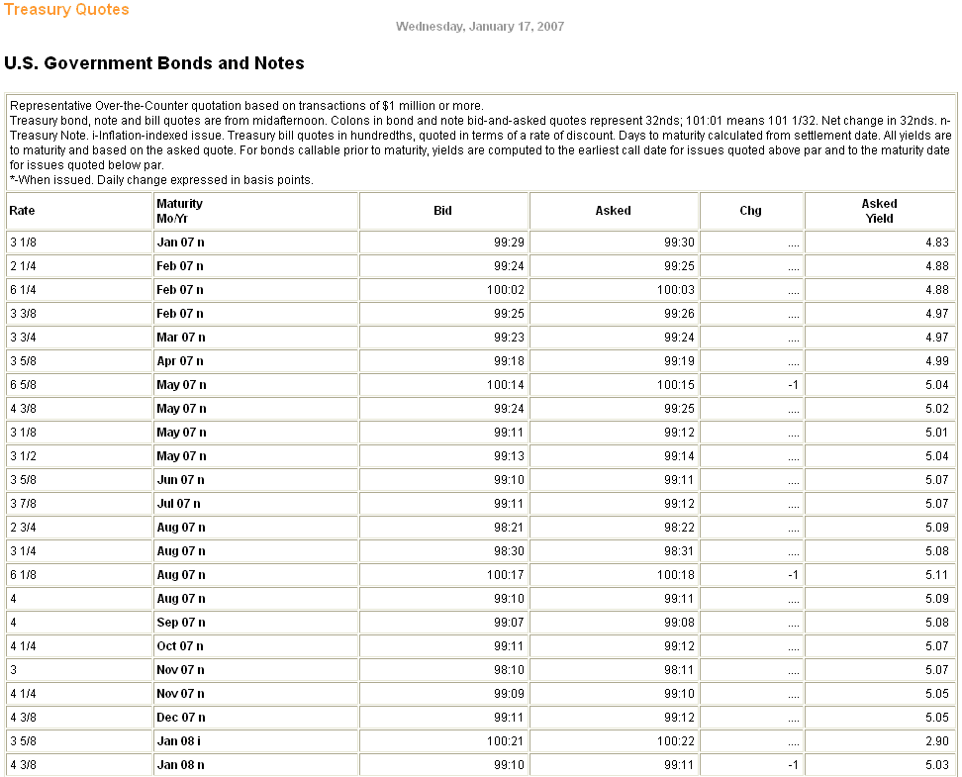

Another type of bond of government bond(state and local) is called a municipal bond. Interest income on municipal bonds is not subject to federal and sometimes state and local tax. To compare yields on taxable securities a Taxable Equivalent Yield is constructed

After tax yield = Before tax yield * (1-tax rate). You must pay federal tax on Treasury’s, but not on a municipal. Example: You are in the 25% tax bracket and are looking at a 8% corporate or T-bond. It’s after tax yield would be 8*(1-.25) = 6%. Thus, a municipal that pays 6.1% would actually be better since you do not have to pay taxes on it.

Finally, there are also convertible bonds. These bonds actually allow you to convert your bond into shares of stock. These bonds typically pay a much lower rate of interest but have great upside if the underlying stock takes off.
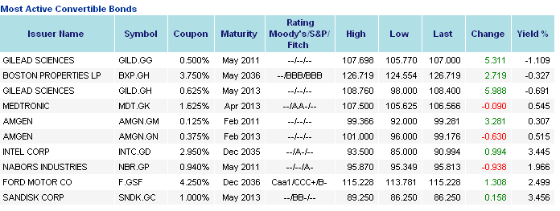

A few review questions: Read chapters 2, 3, and 4 of your text!

Which of the following is(are) characteristic of common stock ownership?
A) voting rights
B) double taxation
C) residual claimant
D) All of the above are characteristics of stock ownership

Which of the following method is used to adjust for a stock split in calculating the standard and Poor's 500 Index?
A) Nothing
B) Adjusting the divisor
C) Adjusting the numerator
D) None of the above

A 10-year annual coupon bond issued by the State of New York has a yield to maturity of 7%. If you are in the 25% tax bracket this bond would provide you with an equivalent taxable yield of __________
A) 7.00%
B) 9.33%
C) 8.75%
D) None of the above

In the event of the company's bankruptcy, __________.
A) the firm's bondholders are personally liable for the firm's obligations
B) the most shareholders can lose is their original investment in the firm's stock plus any legal costs
C) common shareholders are the last in line to receive their claims on the firm's assets
D) bondholders have claim to what is left from the liquidation of the firm's assets after paying shareholders

Assume you purchased 500 shares of ABC common stock on margin at $40 per share from your broker. If the initial margin is 70%, the amount you borrowed from the broker is __________.
A) $4,000
B) $6,400
C) $9,600
D) $6,000

The _________ price is the price at which an investor pays to a dealer to purchase a security.
A) market
B) ask
C) bid
D) None of the above

_________ determines the initial margin requirements on stocks.
A) The Securities and Exchange Commission
B) Stock broker
C) The Federal Reserve
D) The Federal Deposit Insurance Corporation
You purchased 400 shares of XYZ common stock on margin at $20 per share. Assume the initial margin is 60% and the maintenance margin is 30%. You would get a margin call if the stock price is below __________. Assume the stock pays no dividend and ignore interest on margin.
A) $15.71
B) $11.43
C) $13.57
D) $10.14

You purchased 200 shares of AAA common stock on margin for $40 per share. The initial margin is 60% and the stock pays no dividend. Your ROE would be __________ if you sell the stock at $35 per share. Ignore interest cost.
A) 21%
B) 13%
C) -13%
D) -21%

You purchased ABC stock at $50 per share. The stock is currently selling at $49. Your potential loss could be reduced by placing a __________.
A) limit-buy order
B) limit-sell order
C) market order
D) stop-loss order

Short selling a stock is profitable when the stock price __________.
A) does not change
B) goes down
C) goes up
D) None of the above

You sold short 200 shares of XYZ common stock at $40 per share. What is the minimum amount you must place with your broker __________.
A) $4,000
B) $2,400
C) $8,000
D) $5,600
If a company has earnings of $2 and a PE ratio of 20, what must its stock price be?

If a company has a dividend of $1.50 and a dividend yield of 3%, what must its stock price be?

If a company has a 200% stock dividend, what does that mean?
- They issue 1 new share for every share outstanding
- They issue .5 new shares for every share outstanding
- They issue 2 new shares for every share outstanding

A bond rated AAA is considered
- Investment grade
- Junk

A bond rated BBB is considered
- Investment grade
- Junk

A bond rated CCC is considered
- Investment grade
- Junk

A treasury bond is quoted bid 110:04 and ask 110:06. If you sell the bond, how much will you get for it?

A semi-annual coupon bond has a coupon of 7.0. What does this mean?
- You get $7 once a year
- You get $70 once a year
- You get $35 twice a year
- You get $70 twice a year
- You get $35 twice a year

If for some reason the Fed lowered the initial margin to 20%, how much stock could you buy if you had $1,000?

A stock has an average daily trading volume of 10,000 shares with 20,000 shares sold short. Total shares outstanding is 100,000. What is the short interest ratio?

Municipal bonds are tax free. If you are in the 30% tax bracket and a Muni yields 5%, how much would a treasury have to yield to give you the same after tax yield?

