Using the Three Stooges as a Data-Source for Motivation of Statistics Students

Robert Davidson and “Old Bob” Gardner
Math Department Seminar
Monday January 28, 2008
1:40 p.m. Sam Wilson Hall 202

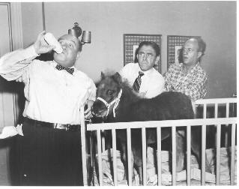

A common approach to engaging students in the undergraduate classroom, is to present them with a topic from popular culture and to interpret the topic in light of the academic area at hand. The presenters will use films of the Three Stooges to provide data for students in a freshman statistics class. Motivation will be given for hypotheses concerning the behavior of the dominant Stooge, Moe, toward the various third Stooges, Curly, Shemp, and Joe. This will allow students to experience the difficulty in designing an experiment, the problems inherent to data collection, and analysis of the collected data.

For more details, contact Dr. Robert Gardner (gardnerr@etsu.edu) of the ETSU Math Department (439-6979), or see http://www.etsu.edu/math/gardner/stooges/stooges-statistics.htm.

