|  | Skype for Business  East Tennessee State University – Information Technology Services |
| --- | --- |

Getting started with Skype for Business

# The Web Scheduler

[https://sched.lync.com](https://sched.lync.com/" \o "Online Skype web application)

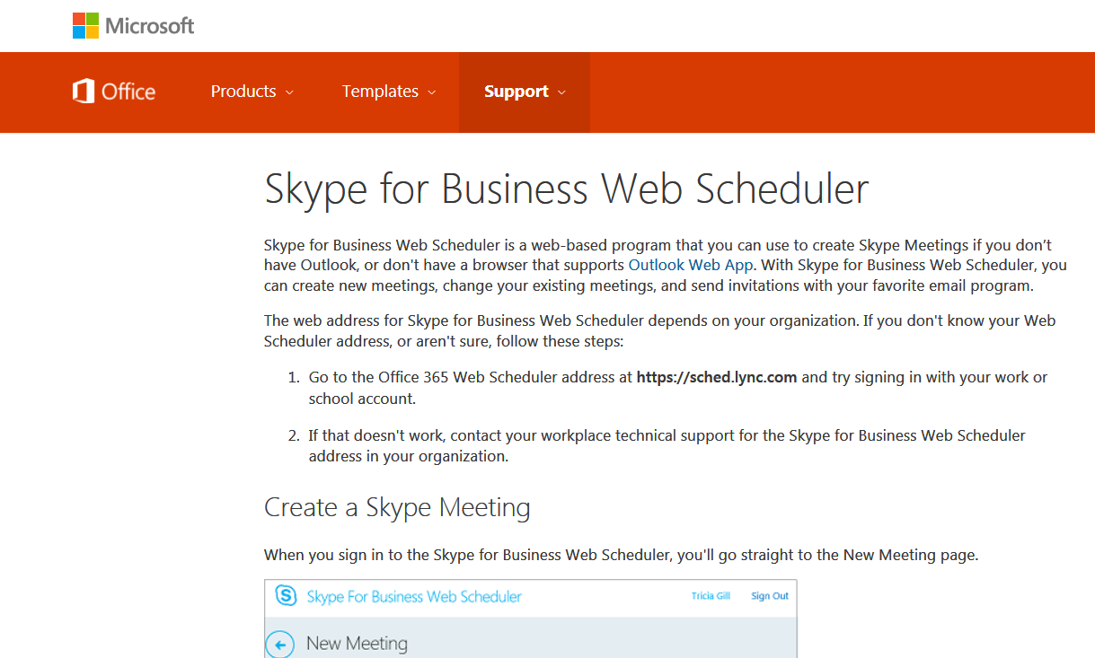

Skype for Business Web Scheduler looks for additional Add-ons that may be helpful to increase productivity. Watch for suggested Add-ons.

Fill in information for the meeting and insert the ETSU Username. Add information or pick selections as needed in the Attendees and Audio field.

Select ‘Check Names’ to confirm the email addresses. If, participants from outside the university will be included, select the ‘Who will bypass the lobby?’ and select ‘Everyone including people outside my company’. Select Save.

Copy the information that appears after Save is selected from the dialog box if URL and details need to be manually sent to participants.

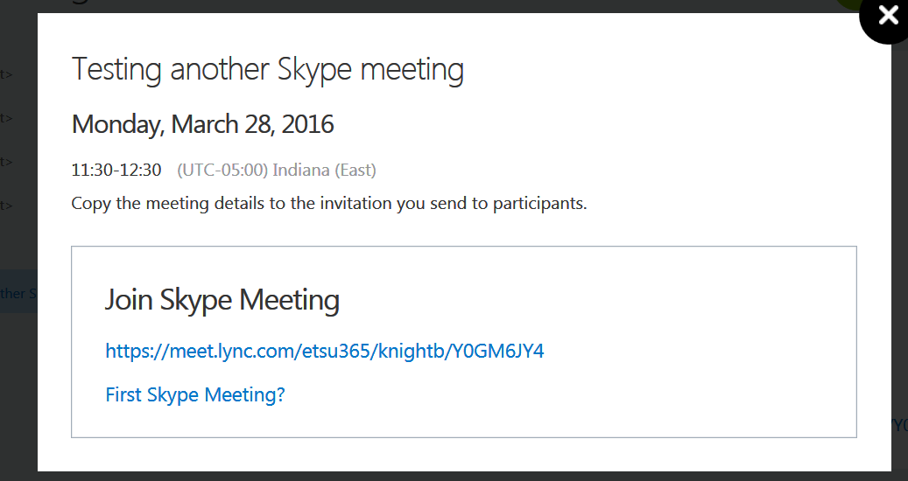

Remind participants to ‘allow’ Skype for Business or to look for a blocked popup.

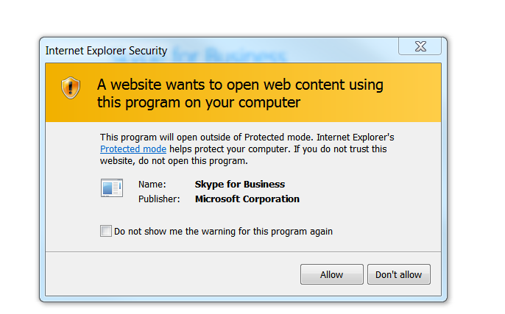

Skype will open and participants will be able to modify options.

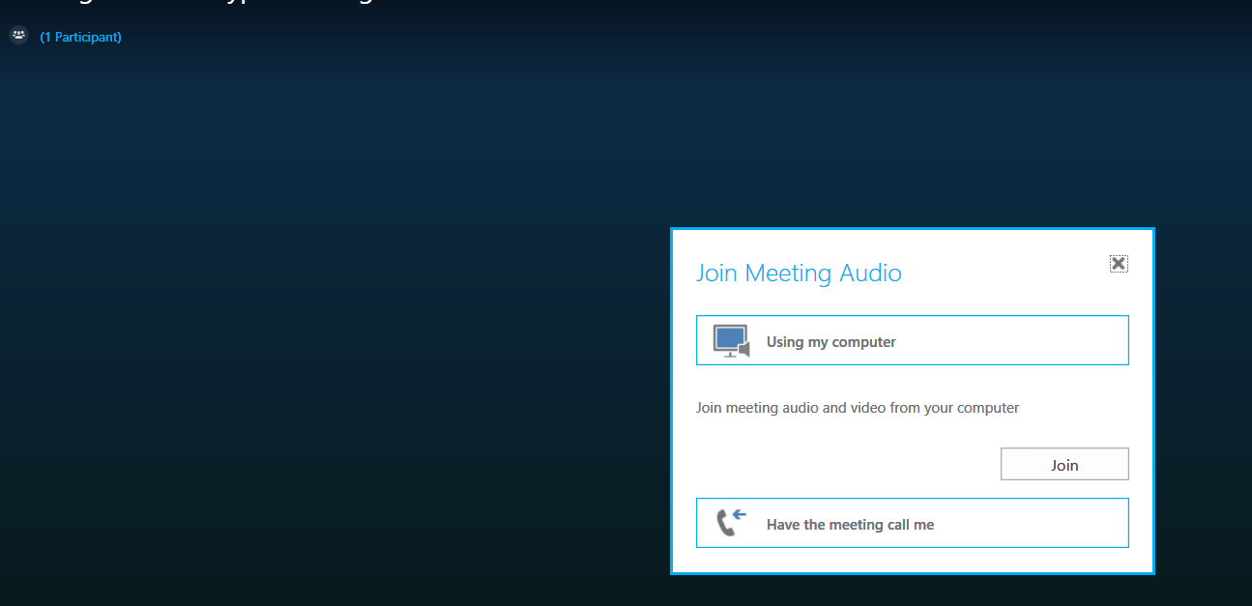

Select the camera icon and or the microphone icon to enable those items.



Select the computer icon to Share Screen, a Program, or Add Attachment for all attendees and more.

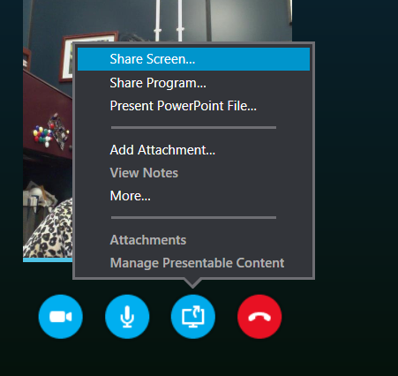

On a PC, you will have the opportunity to download an Add-on for Outlook. Users will see the Add-On in their Calendar Ribbon. On MAC, users will continue to use the OWA (Online Web Application associated with Outlook in 365.

The Skype for Business log in dialog window on a PC, using MS Office 2013, is found under All Programs. It provides other Outlook options, including a Menu bar that can be added by selecting the triangle to the right of the gear icon.



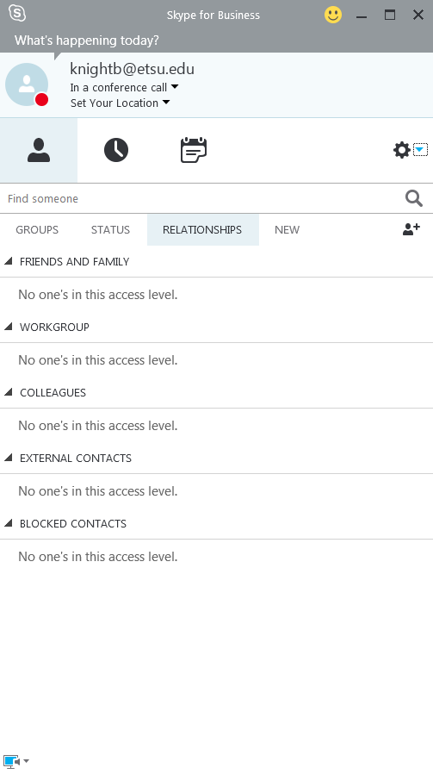

Users will be asked to sign in from the log-in Skype for Business Dialog box in all Programs on a PC. Go to All Programs and search for Skype for Business. Sign in using ETSU username and password.

Once the Add-On is installed on Outlook desktop software, it should appear in the calendar Home Ribbon. If you are signed in using the ETSU username (email) and password, the meeting screen dialog box will open when the Add-on in the Calendar Ribbon is selected.

Outlook software for desktop Add-on is available for Microsoft Outlook 2013. If you are still using Microsoft Outlook 2010, Skype for Business can still be used by going to the [Web App](https://support.office.com/en-gb/article/Set-up-a-Skype-for-Business-meeting-in-Outlook-b8305620-d16e-4667-989d-4a977aad6556?ui=en-US&rs=en-GB&ad=GB) (<https://support.office.com/en-gb/article/Set-up-a-Skype-for-Business-meeting-in-Outlook-b8305620-d16e-4667-989d-4a977aad6556?ui=en-US&rs=en-GB&ad=GB>).

Image below shows the Add-On in the Outlook for PC desktop Ribbon.

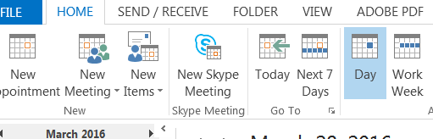

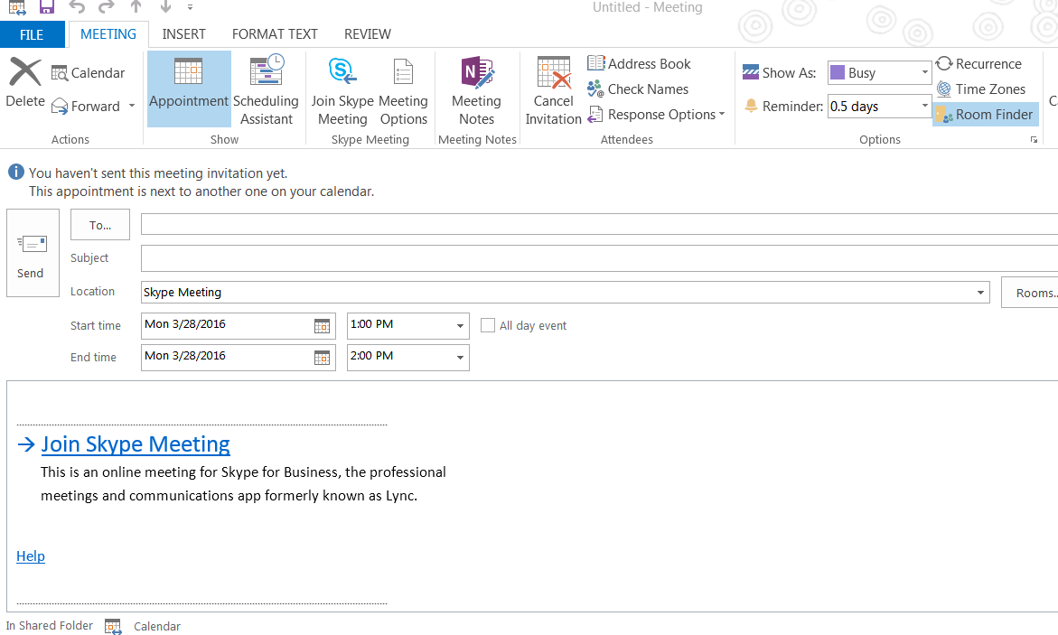

Fill in the ‘To’ option. When participants receive the email, they can click on the Join Skype Meeting. The following box will appear asking how, as a participant, you want to join.

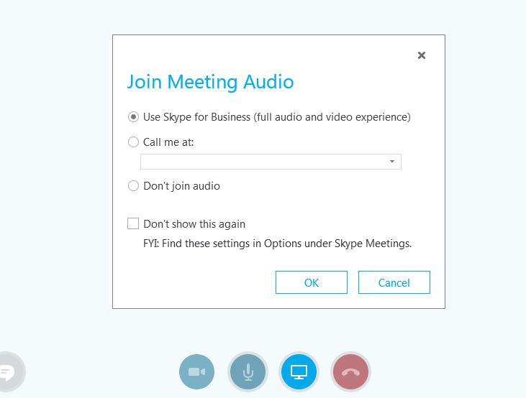

Image of Conversation Pane in Skype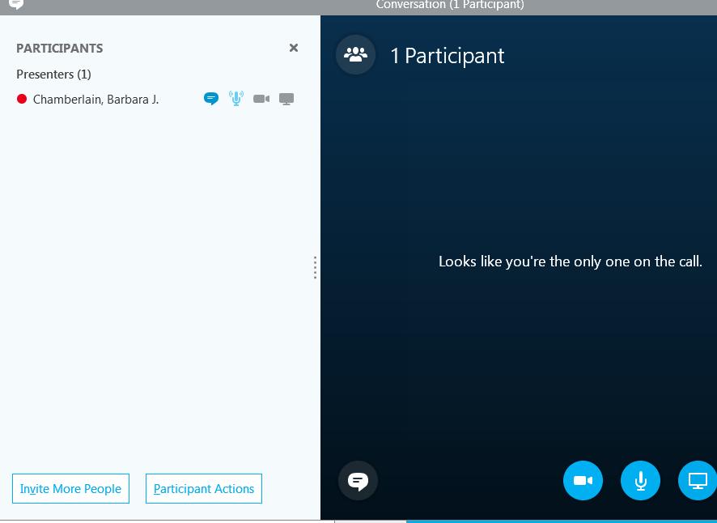

Once the meeting is joined (the organizer can join alone), other people can be invited after the meeting is opened and enabled. Links can also be emailed to others using the information pane, found by selecting the three dots on the lower right corner of the screen.

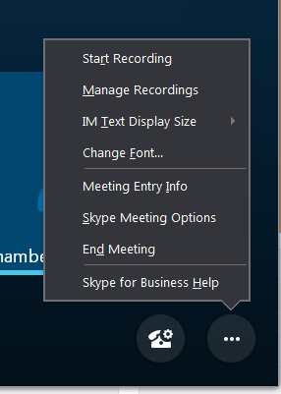

# On a MAC

As of this date, March 28, 2016, I have not been able to place an Outlook Add-On in Office for MAC 2016 desktop software. This is not to say it cannot be done. I am still testing. However, the online web application works Great on a MAC. Also, I did find an app that makes it easy to enter/attend/open a meeting on a MAC by inserting the URL in a simple dialog field.

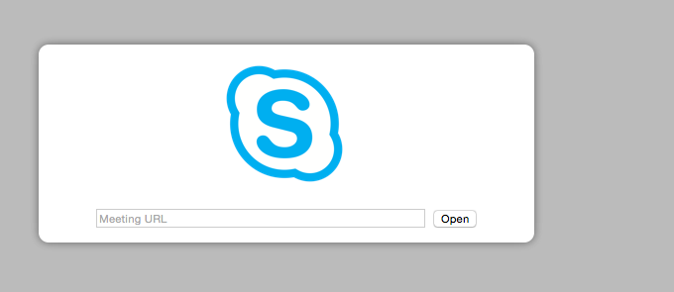

The following image shows the app that can be installed from iTunes app center.

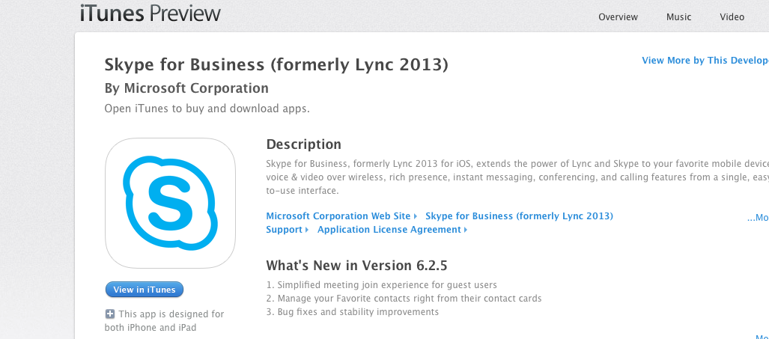

Skype for Business on a MAC from 365.

Open your calendar. Select Skype Meeting. Add the details and participants via email addresses.

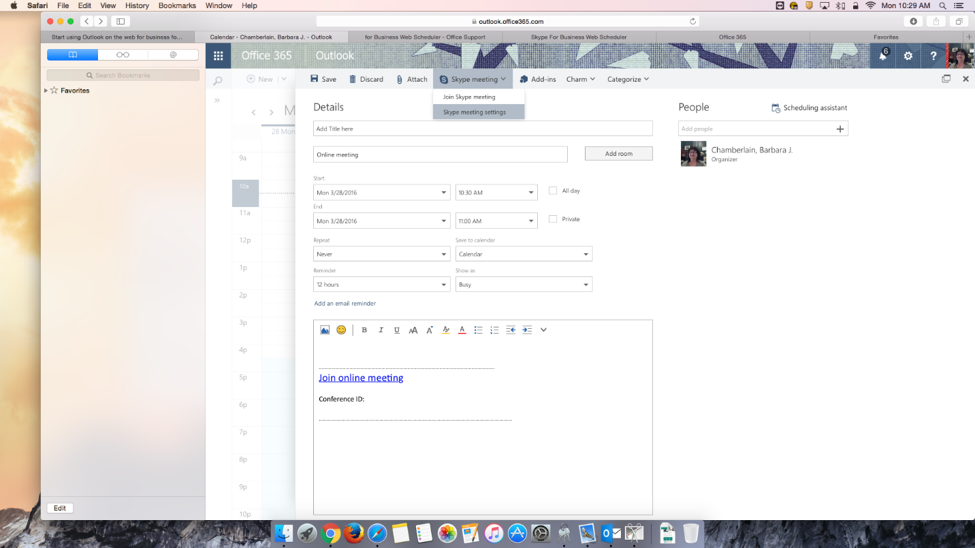

# Additional Information

Once you have added Contacts or Groups, those participants online status will appear. The recent conversations and synch options in this dialog box do not appear to communicate with our Exchange Outlook Software at this time. Although I have set up several test meetings successfully from the Skype Meeting option on my desktop Outlook Software and from my online Outlook Web 365 application and from the web Skype option, none of this meetings appear in my Skype for Business log in dialog box.

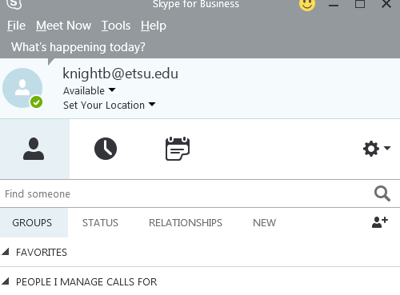

This information is a work in progress from Information Technology Services. Let’s work together to share information. If you discover something related to 365 let us know. Let’s get the most out of Microsoft Office 365.