WSJ Quotes

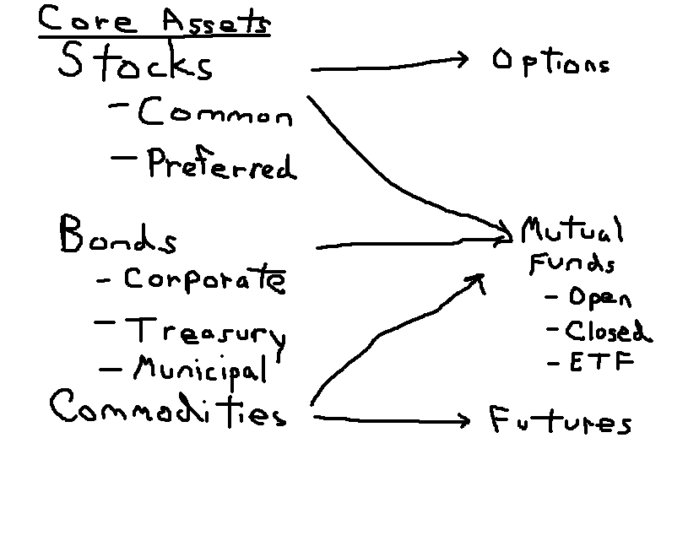

As an introduction to investments, this overview takes us through all the financial assets we will look at this semester. There is a great deal of information here, but I feel it is important that everyone should be able to tell me what these assets are, and how to interpret the quotes that a myriad of financial sites give us.

General Stock Information – Trivial Pursuit Type Information

1) DJIA is the Dow Jones Industrial Index which is composed of 30 large industrial stocks. It is a price weighted index and involves adding up the prices of the stocks and dividing by a denominator. There is also a Dow Jones Transportation Index(20 stocks) and a Utilities Index(15 stocks).
2) The New York Stock Exchange is an actual trading floor located on Wall Street although recently it has gone almost all electronic. There is also the American Stock Exchange, also in New York, the Nasdaq Exchange(computer network), and 5 regional exchanges, the large regional ones being the Pacific in San Francisco, and the Chicago and Boston exchanges.
3) The CBOE, Chicago Board Options Exchange trades options while the CME, Chicago Mercantile Exchange and CBT, Chicago Board of Trade deal mainly with future contracts.
4) There are approximately 3000 companies on the NYSE worth approximately 16 trillion.
5) The S&P 500 is a broader index covering the 500 largest companies in the U.S., it is a value weighted index. The NASDAQ which comes from the National Association of Security Dealers Automated Quotation system is primarily for smaller companies although MSOFT among other large stocks are listed on the Nasdaq. It is laden with tech companies at the moment.

1. Stock Quotes:
Let’s say you had $1,000 back in 1990. You gave it to a couple from Stanford who liked to connect their computer lab’s together who had started a company 6 years earlier. By March of 2000, you would have been worth over a $1,000,000! The tech crash was rather painful for you since you lost $900,000, but by Jan. 2007, you would be back up to over $250,000. Interested???? Stocks can be exciting, just ask some of the millionaire groundskeepers and secretaries at Microsoft who took their Christmas bonuses in the form of stock.

Stocks, often referred to as common equity is a residual claim asset, it has limited liability. You can only lose the amount you buy.
See below for quote. You should know the following terms:
Last = last trading price. NYSE is open from 9:30 to 4 p.m. It is the last price traded that day.
Change = change from the preceding day’s close.
Market Cap = total number of shares outstanding multiplied by the stock price
PE ratio = Price divided by most recent last 4 quarters earnings. It is how much you pay for every $1 the company earns.
Dividend Yield = Dividend/Closing Price for that day.
Short Interest = number of shares sold short.
Short Interest ratio = number of shares sold short divided by the average volume over the preceding month. Basically tells you how long it would take to cover short sells.
Stock split = 100% is a 2 for 1 stock split meaning the company gave you two shares for every one you had. 200% would be a tripling of the number of outstanding shares while 50% for example would be a 1 for 2 split. Often called a reverse stock split meaning that you now only have 1 share for every two that you had.
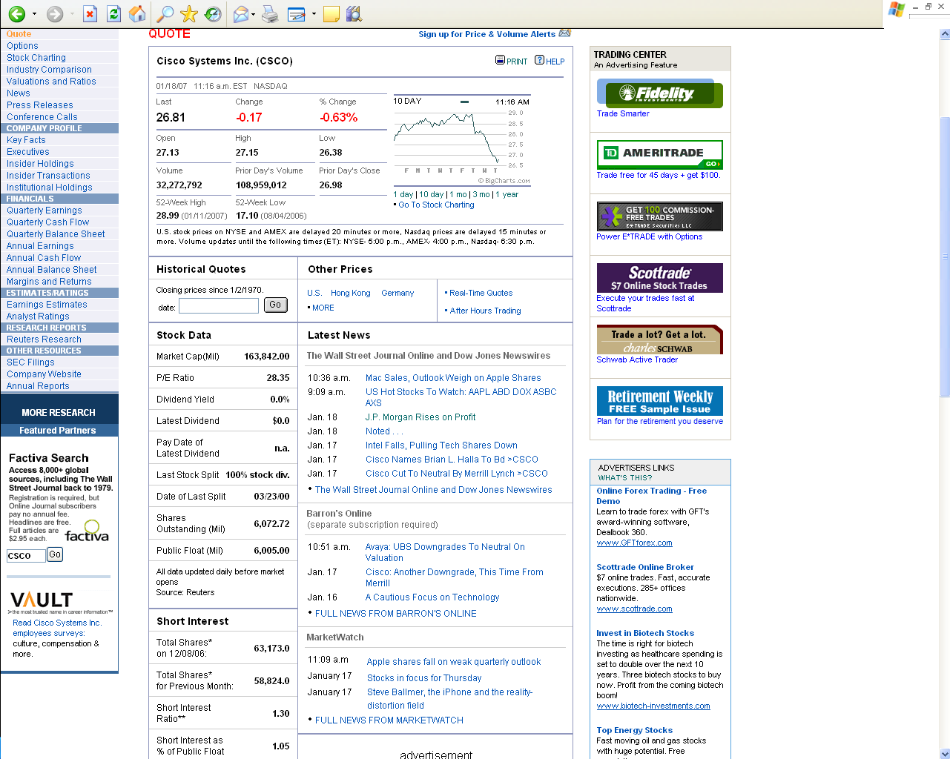

* In thousands
**number of days of average daily volume to close out total short positions.

• Component of S&P 500 Index
Dow Jones Industry Group Center Telecommunications Equipment
Ratings & Estimates
2.1 Mean Recommendation
(1 = Strong Buy,
5 = Strong Sell)
$0.31 Earning Consensus

You should know/learn how to interpret the ratios below. The two that are not self-describe are the current ratio which is current assets/current liabilities and the Quick ratio which is (current assets – inventory)/current liabilities. A value greater than 1 basically means that they have enough liquid assets to meet their Current liabilities.
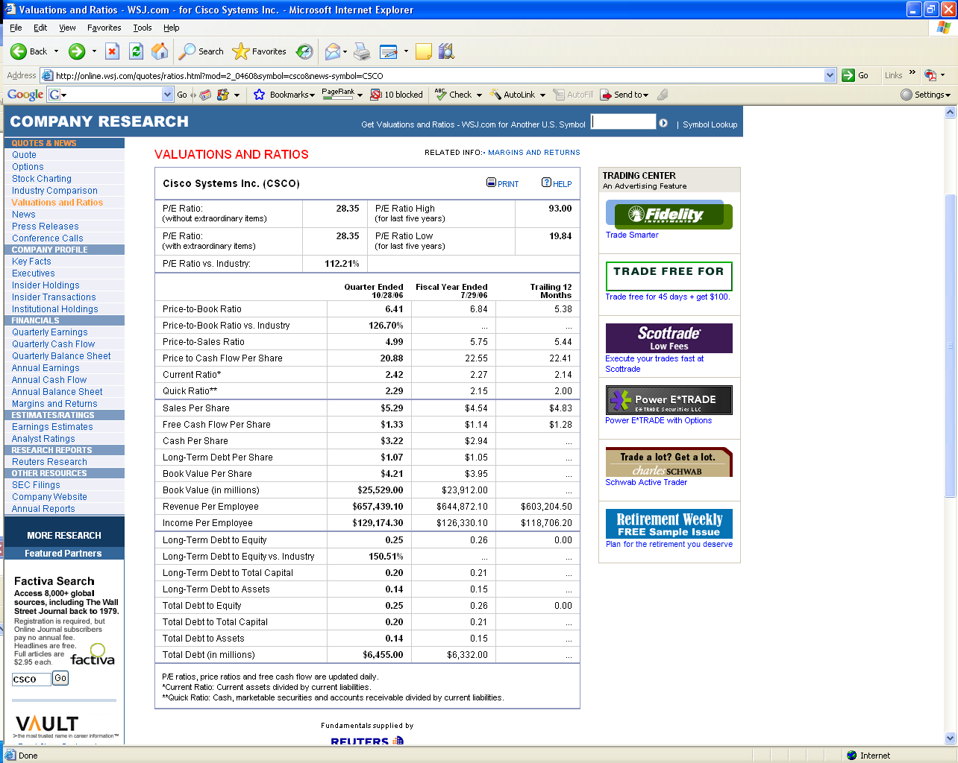

Quote, Home Depot, from Money Central

 | CSCO Intraday Chart  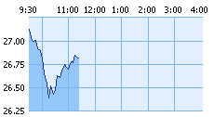  5d 1m 3m 1y 3y 5y 10y
  26.81 -0.17 -0.63%
  Previous Close | 26.98 | Bid | 26.80
  Open | 27.13 | Bid Size | 5,000
  High | 27.15 | Ask | 26.80
  Low | 26.38 | Ask Size | 1,100
  Volume | 34.53 Mil | 52 Week Range | 17.10-28.99
  Market Cap. | 162.81 Bil
  Total Shares Out. | 6.07 Bil
  Avg. Daily Volume | 52.08 Mil
  P/E | 28.40
  Forward P/E | 22.80
  Earnings/Share | 0.95
  Return on Equity | 25.24
  Current Dividend Yield | NA

CSCO, from finance.yahoo. 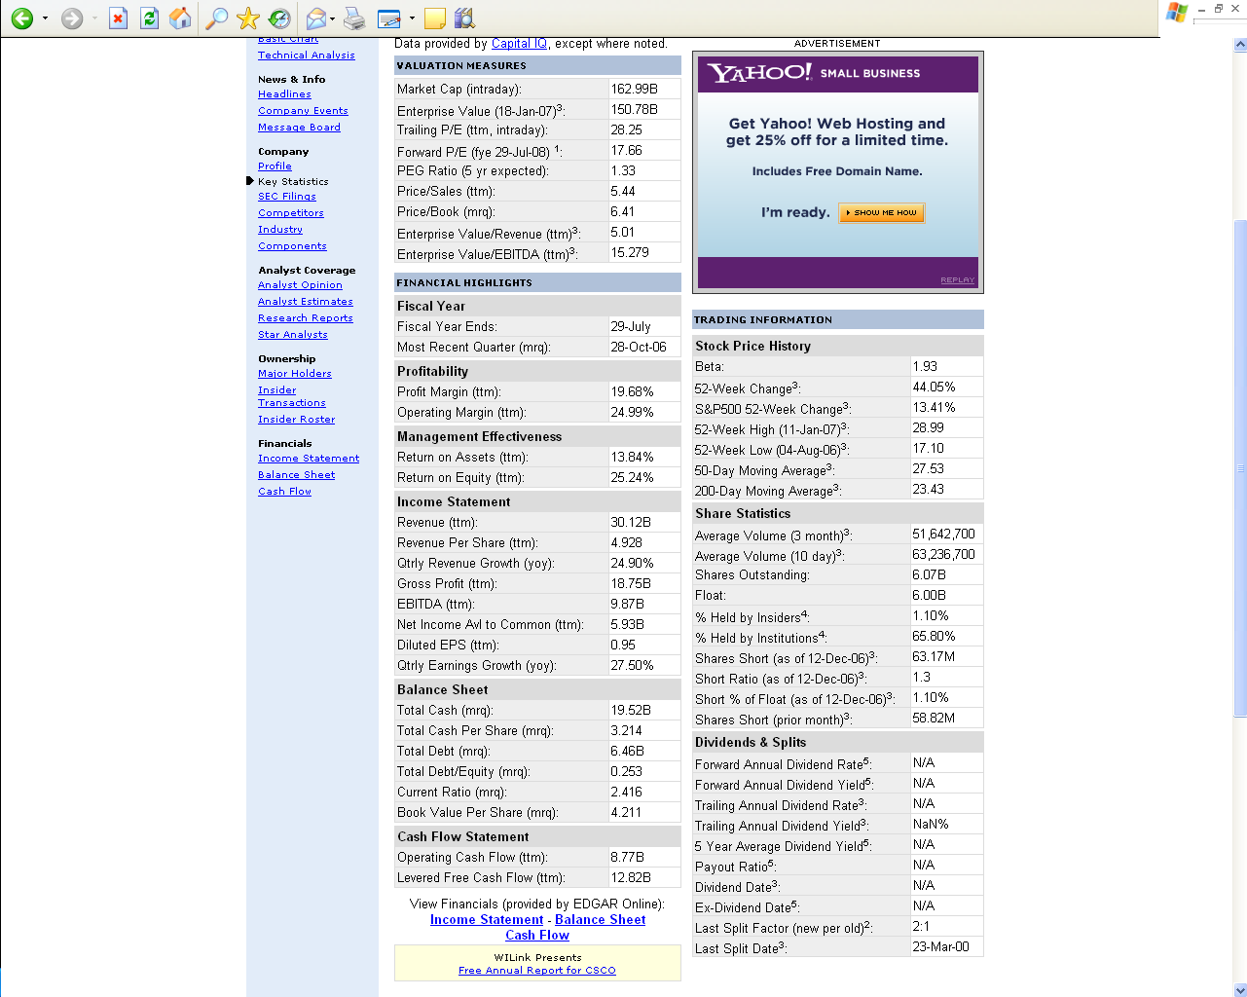

Short Sales – involves borrowing stock and selling it in the market in the hope of buying it back later at lesser price.
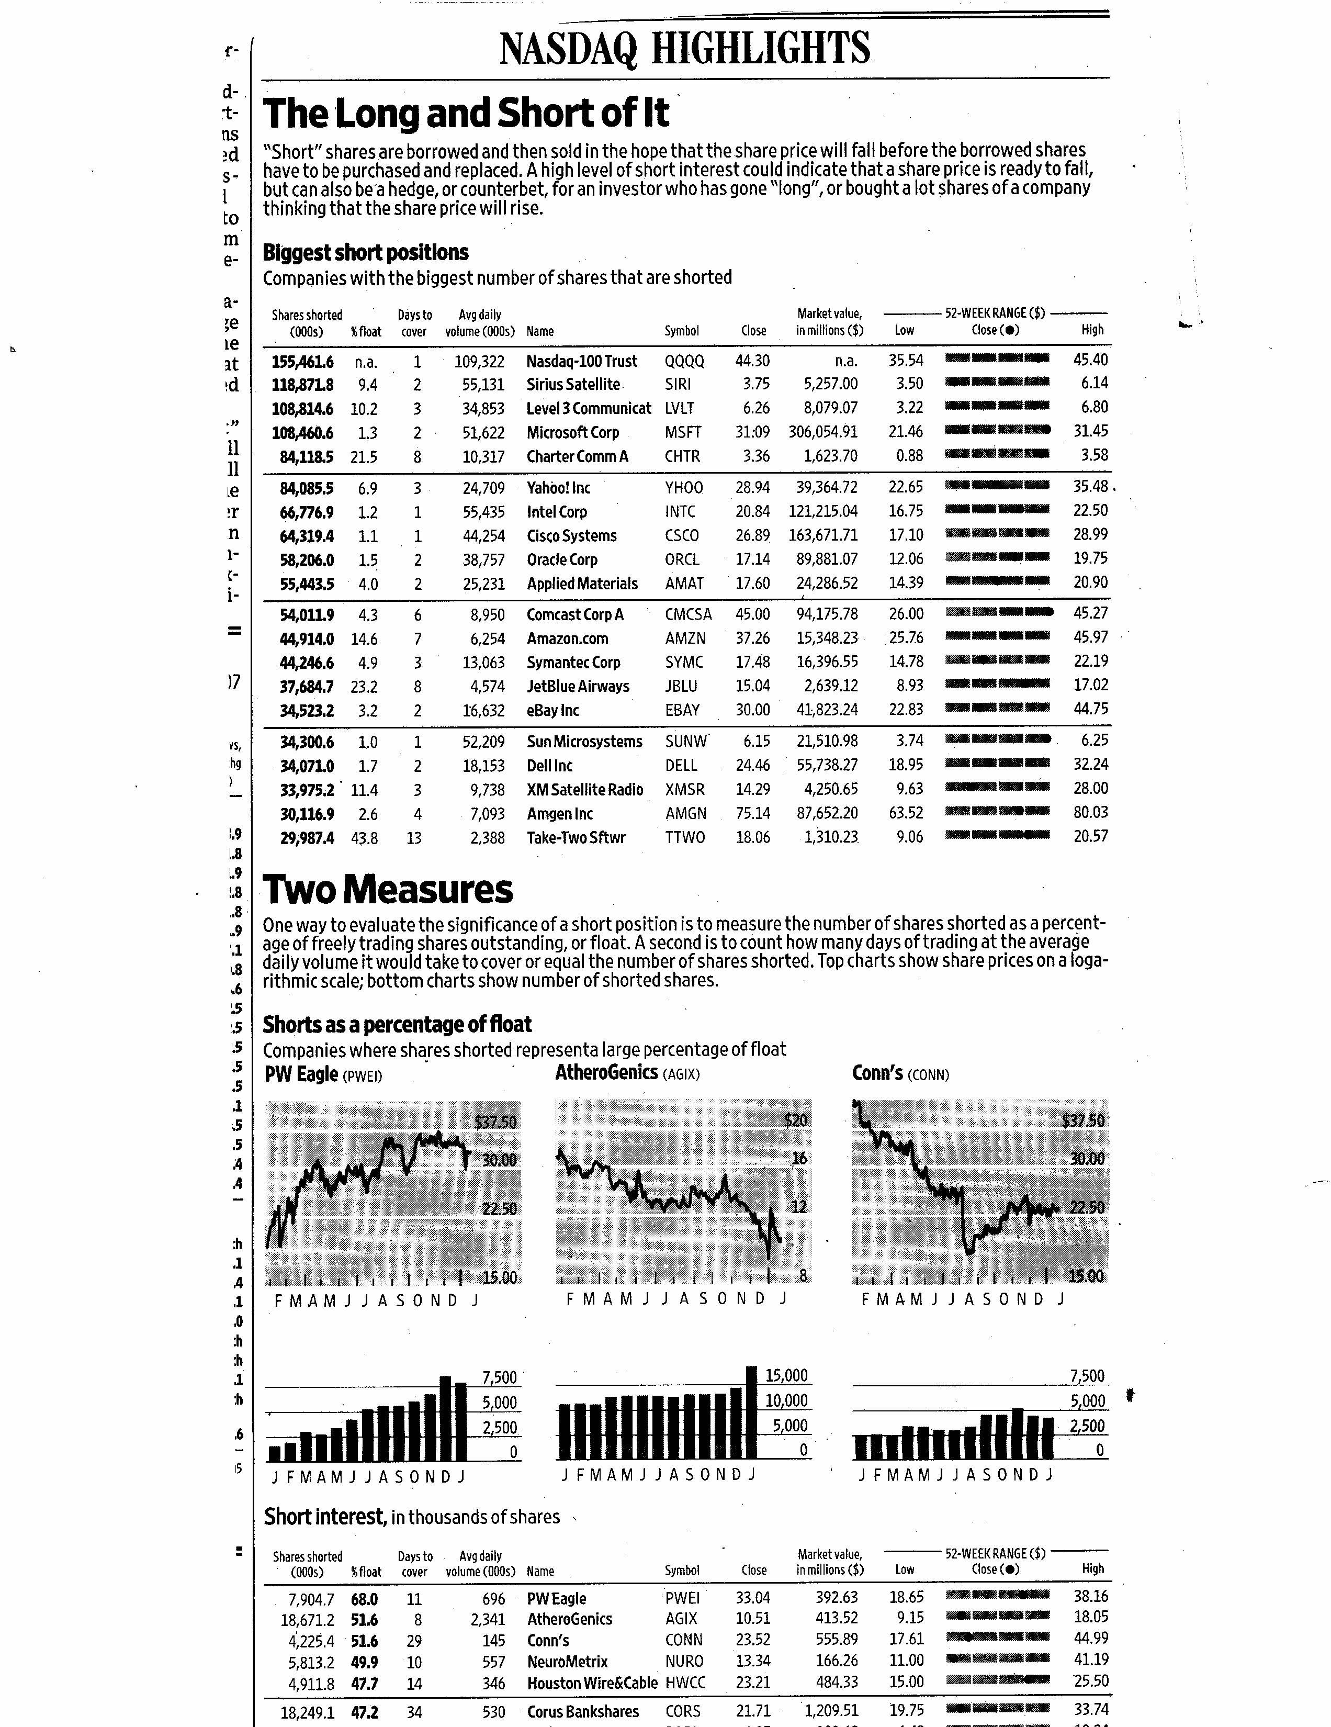

2. Preferred Stocks
Yld is simply dividend divided by price. Dividend is only paid if corporation has cash available. Preferred stock holders cannot force corporation into bankruptcy if they do not pay. Corporations like buying preferred stock from other corporations rather than common stock since 80% of preferred dividends are tax free for corporations. Common stock dividends that corporations receive do not enjoy an preferred tax treatment.
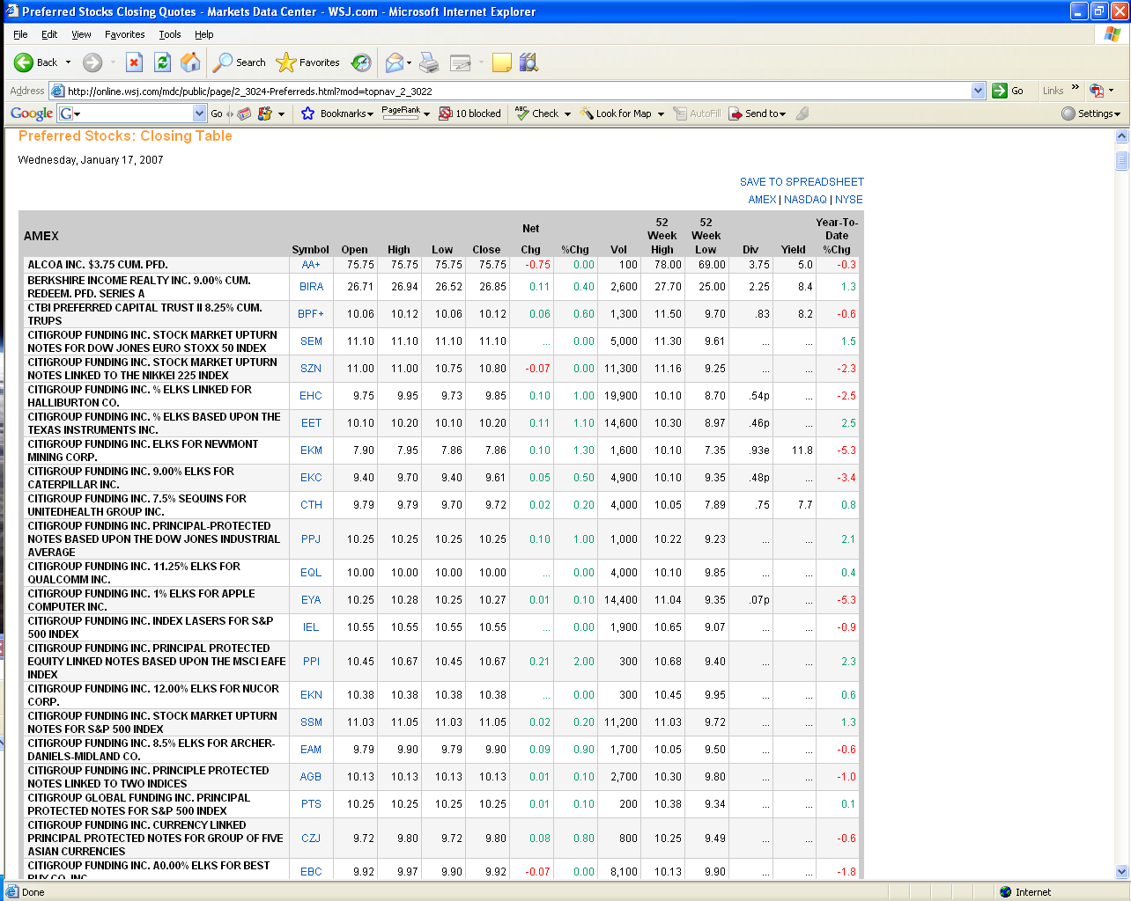

- Corporate Bonds
All bonds mature at par value which is $1000. The coupon is how much you receive each year as a % of par. The Morgan Stanley 5.45% coupon means you receive $54.50 a year until it matures, than you will receive $1,000. Its closing price was $987.44.
Bond ratings go from AAA(Best credit) to CCC. If the rating is D, than it is considered in default. BBB or better is consider investment grade, 0.5% or less chance of default. BB and below, historically default rate is around 4% but has reached above 10% in 90-91, 2001 for example.

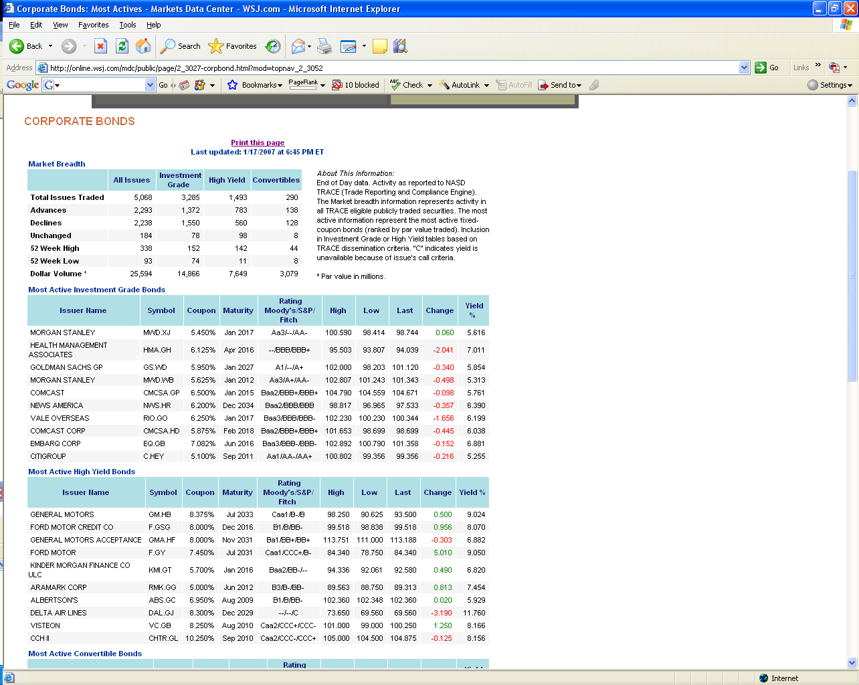

4. Treasury Bonds
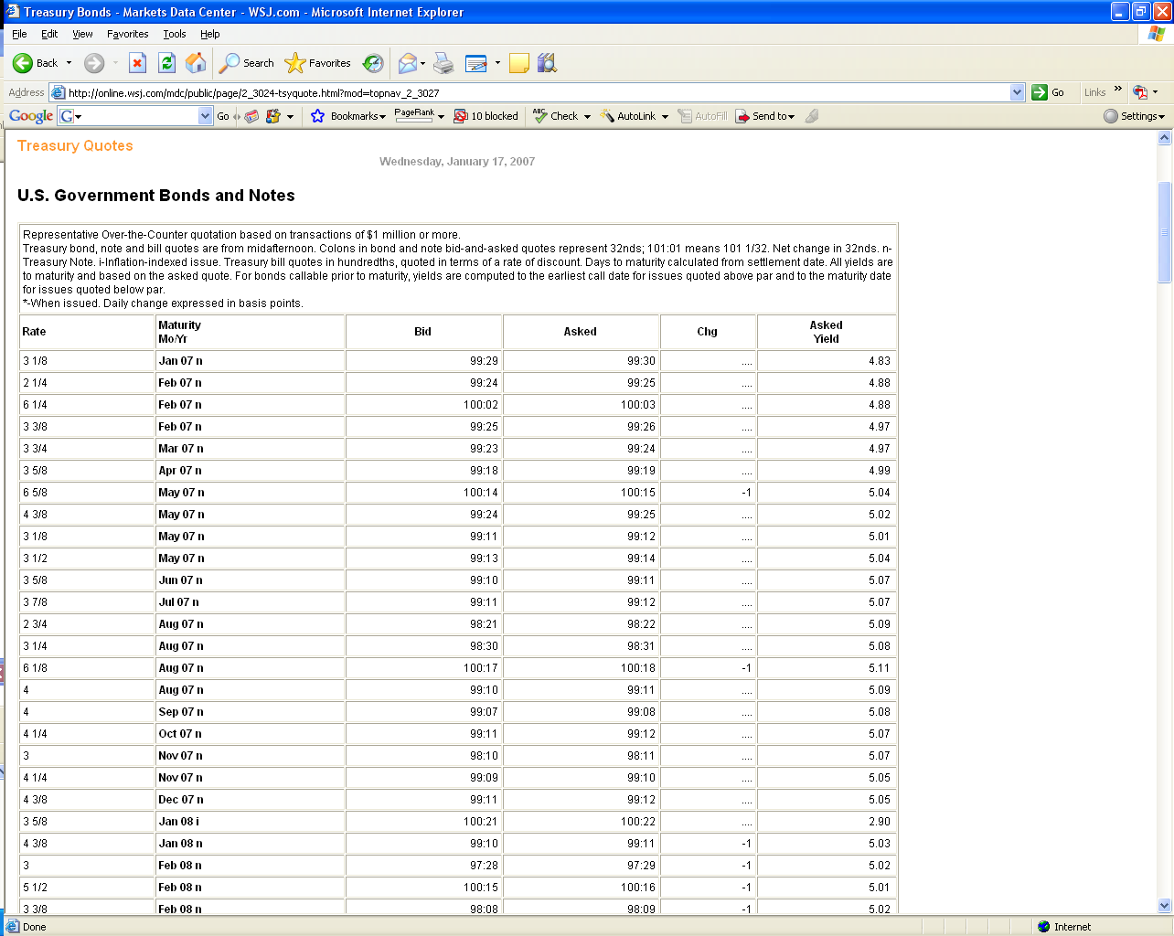

Another type of bond of government bond(state and local) is called a municipal bond. Interest income on municipal bonds is not subject to federal and sometimes state and local tax. To compare yields on taxable securities a Taxable Equivalent Yield is constructed

After tax yield = Before tax yield * (1-tax rate). You must pay federal tax on Treasury’s, but not on a municipal. Example: You are in the 25% tax bracket and are looking at a 8% corporate or T-bond. It’s after tax yield would be 8*(1-.25) = 6%. Thus, a municipal that pays 6.1% would actually be better since you do not have to pay taxes on it.

5. Mutual Funds – Open Ended

Services of Investment Companies

Administration & record keeping

Diversification & divisibility

Professional management

Reduced transaction costs

Costs of Investing in Mutual Funds

Fee Structure

Front-end load

Back-end load

Operating expenses

12 b-1 charges

distribution costs paid by the fund

Alternative to a load

Fees and performance

One special type of fund is a REIT, Real Estate Investment Trust. To avoid taxes on the income this type of fund earns, it must payout 95% of its earnings to holders. It is not strictly a mutual fund per se, but an investment trust.

NAV = net asset value, (value of all assets – liabilities) divided by shares outstanding. Buying and selling prices are only set at the end of the day meaning that when buying and selling open ended mutual funds, you will get the 4 p.m. close price. If you put your order in at 4:05 p.m. you will get the next day’s 4 p.m. closing price.

Expense ratio is how much it cost to run the fund as a percentage of Net assets. Index funds have generally have expense ratios of 0.25% or less. Actively manage funds usually have much higher expense ratios, sometimes exceeding even 2%. Front end and back end loads are the amount you have to pay to invest in the fund. A 2% front end load for example cost you $200 if you invest $10,000 in the fund, meaning only $9,800 is actually invested in the fund. Load funds are often sold by brokers and should generally be avoided.

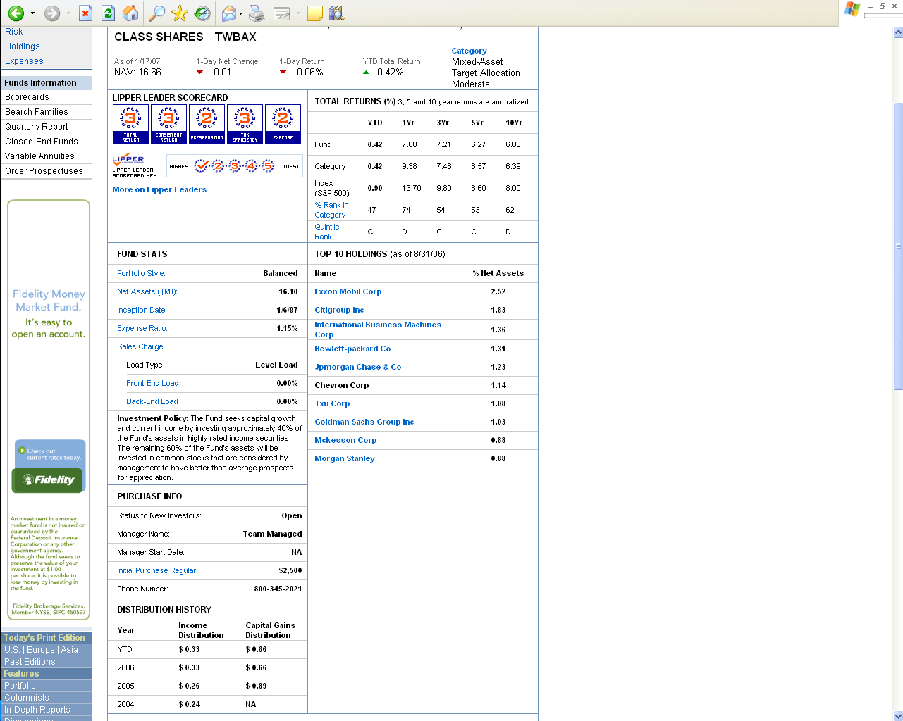
.

6. Closed-End Mutual Funds
Mutual funds not open to new investment. Can only buy from other shareholders. Trade like stocks. Price may or may not equal NAV. The prem./disc. is the difference between NAV and the price.

Open-End and Closed-End Funds: Key Differences

Shares Outstanding

Closed-end: no change unless new stock is offered

Open-end: changes when new shares are sold or old shares are redeemed

Pricing

Open-end: Net Asset Value(NAV)

Closed-end: Premium or discount to NAV

CLOSED-END FUNDS: Emerging Markets Funds | Return to Major Categories | About Closed End Funds
Wednesday, January 17, 2007
 | Weekly Statistics  (as of 1/12/2007) |  |  | Daily Statistics  (as of 1/17/2007)
Fund | NAV | Mkt Price | Prem/Disc % | NAV | Mkt Price | Prem/Disc % | 52 Week  Market Return %
Central Europe & Russia (CEE) | 52.97 | 49.21 | -7.10 | 53.38 | 50.44 | -5.51 | 19.02
Emerging Mkts Telecomm (ETF) | 19.10 | 18.09 | -5.29 | 19.32 | 18.28 | -5.38 | 40.89
First Tr/Abrdn Emerg Op (FEO) | 20.43 | 18.81 | -7.93 | 20.51 | 18.94 | -7.65 | NS
Morg Stan East Europe (RNE) | 35.75 | 37.58 | +5.12 | 36.29 | 38.75 | 6.78 | 30.14
Morg Stan Emerg Mkts (MSF) | 27.45 | 25.96 | -5.43 | 27.84 | 25.75 | -7.51 | 29.71
Templeton Emerging Mkts (EMF) | 17.66 | 17.52 | -0.79 | 17.70 | 17.80 | 0.56 | 2.99
Templeton Russia & E Eur (TRF) ^{c} | 59.48 | 75.95 | +27.69 | 61.47 | 76.08 | 23.77 | 43.57
Source: Lipper Inc.

7. Exchange-Traded Funds
These are mutual funds which you can trade during the day and receive the price at that time. Price should be very close to NAV throughout the day.

ETF allow investors to trade index portfolios like shares of stock

Examples - SPDRs andWebs

Potential advantages

Trade continuously

Lower taxes

Lower costs

ETF Price Tables
Wednesday, January 17, 2007
Exchange-traded funds, latest session
ETF | Symbol | % Yield | Close | Chg | % Chg | YTD  % chg
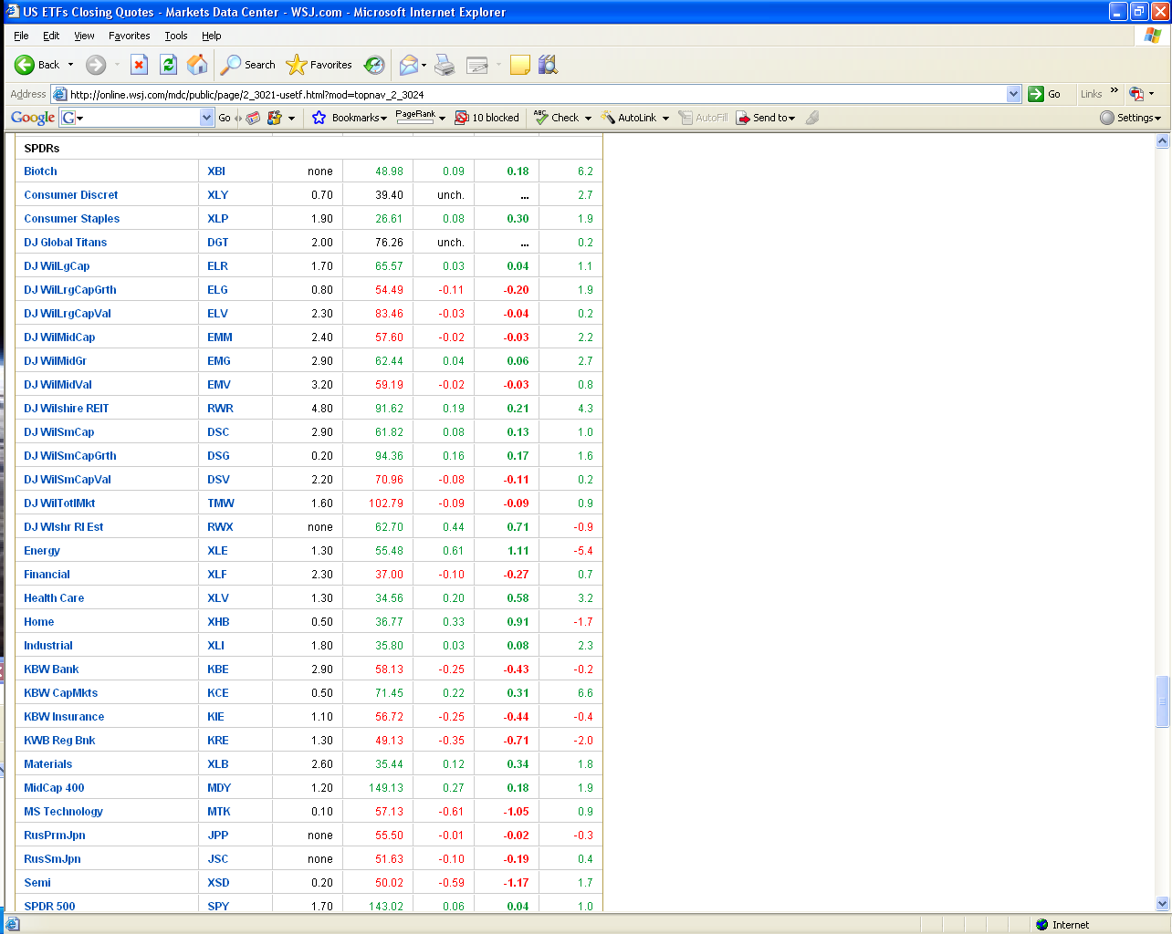

8. Options
Options expire on 3rd Friday of expiration month.
Buy a Feb 25 call option, right to buy 100 shares at $25 a share on or before 3rd Friday in February. Would cost you $2.40 per share or $240 for this option.
Sell Feb. 25 call option, obligation to sell 100 shares at $25 a share, receive the $240.
Buy Feb. 25 Put option, right to sell 100 shares at $25 a share on or before 3rd Friday in February. Would cost you $30 total.
Sell Feb. Put option, obligation to buy 100 shares at $25. Receive $30 for writing the put option.

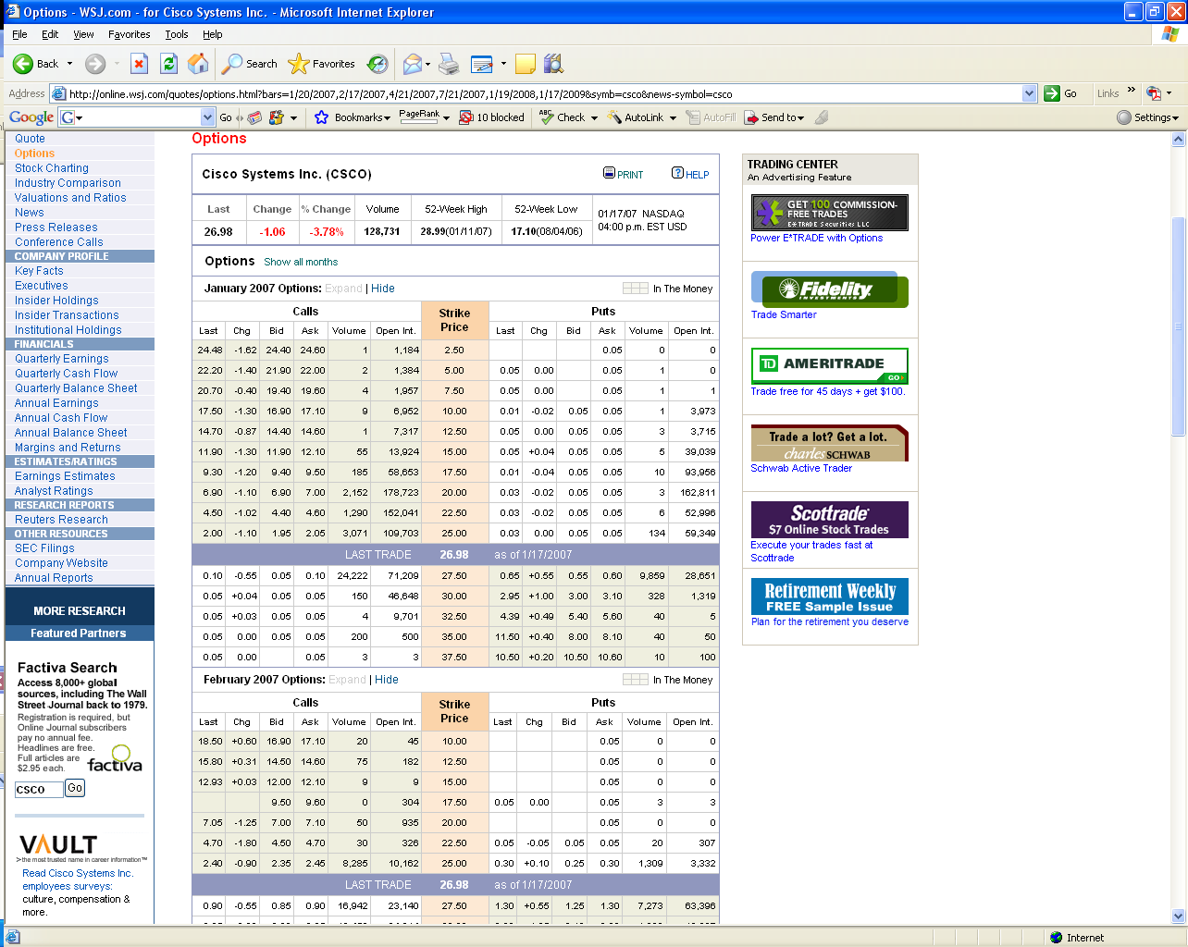

- Futures
“One minute you're up half a million, the next, boom. Your kids don't go to college and you've lost your Bentley.”
-Winthorpe AKA Dan Akroyd, Trading Spaces, 1983

Why Futures Markets are so exciting!!!!!!!!!!!!!!!!!!!!!!!!! Even Hollywood knew futures markets were exciting based on the Trading Places movie.
The movie was based on a reversal of fortunes dealing with OJ futures. Here is how Hollywood detailed it.
Orange Juice futures are for 15,000 pounds(sold in concentrate) and each contract is priced in cents per pound. Currently around $1.75 per pound(2007). However, the movie had the price around $1.02 per pound. The subplot for the movie is that Valentine and Winthrope have managed to attain the real crop report which has not been announced yet and the “Dukes” have the false report saying the weather is bad and the harvest is less than normal. Thus, they think the price is going up and Valentine and Winthorpe know it is going to fall. Thus, the Duke’s agent goes long or starts buying contracts. Because of this, the price gets pushed up to 142. At this point, Valentine and Winthorpe start going short or selling contracts. This drives the price back to 102. The crop report comes out and the price tumbles to 46 at which time Valentine and Winthorpe buy back all their contracts(20,000) at this point. They do not buy any from the Dukes agents which sticks them with all contracts they bought and the market closes at 29.
So, how much did Valentine and Winthorpe make? If we postulate they sold at an average price of 122 and bought at an average of 38, they made:
$1.22 – $0.38 * 15,000 pounds per contract * 20,000 contracts for $252,000,000!!! Now that’s some cash.
The Dukes end up losing $394,000,000 which is not hard to imagine based on our analysis above.

Because of market circuit breakers, this couldn’t really happen as the market would be halted with such large movements in the price, but....real trading losses in the last 10 years make Hollywood’s version quite tame.

Nick Leeson and Barings Bank
The week before Nick Leeson disappeared he kept throwing up at work.  Colleagues did not know why, but were soon to find out.  The ego of a 28-year-old trader on the Singapore Monetary Exchange and the greed and stupidity of a 233 year-old bank had combined to destroy an investment empire, and in the process stunned the world. | 
Nick Leeson's life started as a classic rags-to-riches tale. He was the working class son of a plasterer from a Watford council estate, who failed his final maths exam and left school with a mere handful of qualifications. Nevertheless, in the early 1980s, he landed a job as a clerk with royal bank Coutts, followed by a string of jobs with other banks. He finally settled up with Barings, where he quickly made an impression and was promoted to the trading floor.
Before long, he was appointed manager of a new operation in futures markets on the Singapore Monetary Exchange (SIMEX) and was soon making millions for Barings by betting on the future direction of the Nikkei Index. His bosses back in London, who viewed his large profits with glee, trusted the whizzkid. Leeson and his wife Lisa seemed to have everything: a salary of £50,000 with bonuses of up to £150,000, weekends in exotic places, a smart apartment and frequent parties. To top it all they even seemed to be very much in love.
The job of a derivatives trader is akin to a book maker once removed: taking bets on people making bet. Leeson started by buying and selling the simplest kind of derivatives futures pegged to the Nikkei 225 - the Japanese equivalent to the UK's FTSE 100.
At the time, the trader only had to put down a small percentage of the amount that was being traded. It was therefore easily possible for the money on the table to be exceeded many times by losses. However Leeson seemed to be infallible to Barings Chief Executives and by the end of 1993, he had made more than £10m - about 10 per cent of total profit that year.
Barings believed that it wasn't exposed to any losses because Leeson claimed that he was executing purchase orders on behalf of a client. What the company did not realise was that it was responsible for error account 88888, where Leeson hid his losses. This account had been set up to cover up a mistake made by an inexperienced team member, which led to a loss of £20,000. Leeson now used this account to cover his own mounting losses.
In a fatal mistake, the bank allowed Leeson to remain Chief Trader while being responsible for settling his trades, a job that is usually split. This made it much simpler for him to hide his losses.
By December 1994 the red ink hidden in account 88888 totalled $512million. Getting increasingly desperate Leeson bet that the Nikkei index would not drop below 19,000 points. At the time this seemed reasonable as the Japanese economy was rebounding after a 30 month recession. Then on the 17th January 1995, a devastating earthquake measuring 7.2 hit the Japanese city of Kobe.
The previously stable Nikkei index plummeted by 7% in a week. As the losses grew, Leeson requested extra funds to continue trading, hoping to extricate himself from the mess by more deals. Leeson was counting that there would be a post quake rebound and the Nikkei would stabilise at 19,000. There were no hedges, no bets the other way to protect Barings' huge exposures. There was no rebound. Over three months he bought more than 20,000 futures contracts worth about $180,000 each in a vain attempt to move the market. Some three quarters of the $1.3 billion he lost Barrings resulted from these trades. When Barings executives discovered what had happened, they informed the Bank of England that Barings was effectively bust.
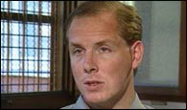
Two days before his 28th birthday Nicholas William Lesson went missing from Singapore, on his desk he left a hurriedly scribbled not saying "I'm Sorry." He guessed he would be jailed for the fraud and in the hope of being locked up in the UK rather than the Far East - the couple went on the run. He went first to an exclusive resort in Borneo and then to Frankfurt.
The worlds most wanted man, on the cover of every newspaper, checked in on his flight to Europe using his own name and hiding beneath a baseball cap. The German authorities were alerted and the police were there to greet Leeson as he touched down. On the news of Leeson's arrest, cheers erupted in the worlds futures markets.
In his wake he had wiped out the 233 year-old Baring investment Bank, who proudly counted the Queen as a client. The 1.3billion dollars of liabilities he had run up was more than the entire capital and reserves of the bank. Investors saw their savings wiped out and some 1,200 of Leeson's fellow employees lost their Jobs. Dutch bank ING agreed to assume nearly all of Barings' debt and acquired the bank for the princely sum of £1.
Who was to blame? Leeson definitely. He pleaded guilty to forging documents and misleading SIMEX, but as the dust settled from the Barrings collapse, the famous line from the Watergate prosecution was asked, 'What did the President know and when did he know it?' Although there is no doubt about Leeson's deeds, could senior bank officials not have known of the rogue trader's actions?
The Bank of England concluded in its report, that the hot-shot trader managed to pull the wool over his superiors eyes until it was too late to save the bank. It was certainly a fact that most of the old school really never understood or cared to master the complexities of derivatives trading.
But Barings could not totally escape blame. An internal memo dated in 1993 had warned the London headquarters about allowing Leeson to be both trader and settlement officer, "We are in danger of setting up a system that will prove disastrous." Nothing was done. In January 1995 SIMEX expressed concern to the bank about Leeson's dealings, but to no avail as the bank still wired him $1billion to continue his trading. A report by the Singapore authorities into the collapse regards with disbelief the protestations by Leeson's superiors, all of who were forced to resign or were sacked, that they knew nothing of error account 88888.
What became of Leeson? After his arrest in Germany he spent a few fraught months trying to escape extradition to Singapore. He failed and in December 1995 a court in Singapore sentenced him to six-and-a-half years after he pleaded guilty to two counts of deceiving the bank's auditors and of cheating the Singapore exchange. Having served nearly nine months in Germany awaiting extradition, his sentence was backdated to March 2nd, 1995.
In jail, he is said to have exercised vigorously, "found God" and spent his days walking up and down, pacing away the time.
The fortunes of Leeson's personal life also seemed to mirror the peaks and troughs of his career. As if in a soap story, his wife Lisa got a job as an air hostess to be able to visit him regularly. She even helped him write his book, 'Rogue Trader'. Their marriage at first survived the strain of being apart. But what Lisa could not abide were his revelations of his infidelity with Geisha girls, so she divorced him. Her remarriage, to another City trader, served to further knock his spirit and he grew very depressed at losing his once devoted wife. Within months, Leeson was diagnosed as suffering from cancer of the colon, the disease that had killed his mother. He had successful surgery whilst in prison. From being a partying, good-time youngster who could abuse his body with heavy drinking, he was reduced to a ghost of a man.
He was released early, in the summer of 1999 and his return to the UK brought a realisation that the high life had been swept away; he was effectively homeless and without a job. Yet Leeson has proved his resilience and has been able to capitalise on his experiences. He made an estimated £50,000 from his book and the fee for newspaper serialisation is reported to be about three times that amount.
When the story was turned into a film 'Rogue Trader' starring Ewan McGregor, Leeson was thought to have received a considerable sum from the proceeds. His notoriety has also made him hot property on the conference circuit where he makes considerable sums speaking about his experiences.
"I don't think of myself as a criminal" Leeson said before he was tried in Singapore, he has always claimed he made no personal gain from his trading and was merely trying to cover losses.

Losing a $1 billion is bad, how about $5 billion in a week…

What went wrong at Amaranth Advisors
Wednesday, September 20, 2006
By Ann Davis in Houston and Henny Sender and Gregor Zuckerman In New York, The Wall Street Journal
One of the mistakes that led to Amaranth Advisors' multibillion-dollar losses on natural-gas investments is a common one in fast-shifting energy markets: confusing paper trading gains with cash profits.
The hedge fund's chief energy trader, 32-year-old Brian Hunter, misgauged when to take his chips off the table, losing roughly $5 billion in a week for a hedge fund that boasted of world-class risk-management systems. While Amaranth had traded energy for several years, its roots were in convertible-bond trading, a different, less-volatile market.
According to natural-gas investors who traded alongside Amaranth, Mr. Hunter repeatedly used borrowed money to double-down on his bets. Buying more futures contracts of the kind his fund already owned supported their price by increasing demand, propping up paper gains, these traders say. But that support only lasted as long as Amaranth and its lenders were willing to spend cash to buy more contracts. Such trades may also have masked growing weaknesses in market fundamentals, his trading peers say.
As Connecticut Attorney General Richard Blumenthal vowed to investigate the losses, the once-mighty Greenwich-based hedge fund scrambled to explain to investors how risk controls went awry, cutting assets to about $4.5 billion, from $9 billion.
Working from Calgary, Alberta, Mr. Hunter employed a routine commodities strategy, exploiting the difference between the prices of contracts for delivery of natural gas at various future points. He also was buying options to buy or sell natural gas at prices that others in the market thought unlikely but that would provide big payoffs if the prices came to pass. Both strategies are supposed to be less risky than simply betting that prices will move either up or down.
In an Aug. 29 interview, when Mr. Hunter still had big paper gains, Amaranth Chief Executive Nick Maounis said his bets were meant to minimize risk and maximize reward. "Spreads and options are of their very nature instruments for positions which are designed to allow the user to capture upside with a much clearer understanding with respect to downside exposure," he said.
Mr. Maounis was unavailable Tuesday. In a letter to investors Monday, he said the fund so far had met all demands for more cash to back trades and was unwinding natural-gas bets "to preserve investor capital." An Amaranth spokesman declined to comment. Mr. Hunter has not responded to recent interview requests.
By early September, as prices fell precipitously because of a storage glut, Mr. Hunter held bets that would pay off exponentially only if natural-gas prices rebounded, either on the prospect of a cold winter or a nasty hurricane that hit natural-gas facilities. But as evidence pointed to a meek hurricane season and mild winter, prices fell more.
Amaranth's systems didn't appear to measure correctly how much risk it faced and what steps would limit losses effectively. The risk models employed by hedge funds use historic data, but the natural-gas markets have been more volatile this year than any year since 2001, making models less useful. They also might not predict how much selling of one's stakes to get out of a position can cause prices to fall.
"It was a total failure of risk control to put your entire business at risk and not seem to know it," says Marc Freed, a managing director at Lyster Watson & Co., an advisory firm that invests in hedge funds for clients but not with Amaranth. "They were more leveraged than they realized."
Commodities trades require less margin money -- collateral to be surrendered in case of losses -- upfront than other markets. On the main exchanges, traders typically post 10 percent of their position's value, whereas in the stock market, 50 percent is common.
So say, for example, gas is trading at $7 per million British thermal units and a trader buys one contract to buy or sell 10,000 million-BTUs for $70,000. That trader posts just $7,000 to make that bet. If the price of gas goes down 10 percent, the trader has to post another 10 percent, or $7,000. The trader now has $14,000 tied up in the market, and the value of his position has dropped to $63,000.
Compound that with generous lines of credit from banks, and it is easy for commodity hedge funds to get highly leveraged quickly.
Funds like Amaranth are able to borrow three to eight times their initial capital to make bets thousands of times over. Mr. Hunter sometimes held 100,000 positions in a single contract, say traders familiar with his bets.
The volatile trading that distinguished Mr. Hunter was a departure for Amaranth. Denis Joseph, Amaranth's senior vice president for human resources until 2004, said Mr. Maounis, the CEO, sought to centralize oversight of traders and to keep big discretionary trading authority on the fund's Greenwich trading floor. After big gains in 2005, Mr. Hunter was allowed to trade from Calgary. "To have a relative newcomer ... receive so much discretion is just shocking to me," Mr. Joseph said.
Still, the fund's high returns from energy last year and earlier this year were popular with its investors. When Amaranth reported returns of roughly 12 percent in April, it told investors most of that profit was from energy trades. After Amaranth lost about 10 percent in May, or roughly $1 billion, mainly on energy trades, it told some investors that it was cutting back on leverage in the energy market, the investors say.
Mr. Hunter's bets ultimately went bad because he misjudged the movement of the difference between prices for different month contracts, known as the spread. People familiar with the trades say he bet prices for nearby-month contracts months would fall and winter contracts would rise. These people say he also presumed gas might be scarce in March if use was heavy this winter and prices would then fall off in April.
The fund closed down two weeks after this article with a $6 billion dollar loss in September.

Yet another example is Long-Term Capital Management who actually had Myron Scholes and Robert Merton on the board(they shared the 1997 Nobel Prize in Economics) and were the original founders of option pricing theory. The Black-Sholes option pricing model literally help create the explosive growth in the use of options. They lost $4.6 billion in four months in a variety of options, swaps, and supposedly “safe” arbitrage positions.

So, lets look at how this works:
FUTURES:
Both parties have obligation to perform. Money does not change hands initially, only after the price changes.
Long Mar 07 Gas, Futures, obligated to buy 42,000 gallons of gas for $1.41 a gallon on the third Friday of March.
Short Mar 07 Futures, obligated to sell 42,000 gallons of gas for $1.41 a gallon on the third Friday of March.

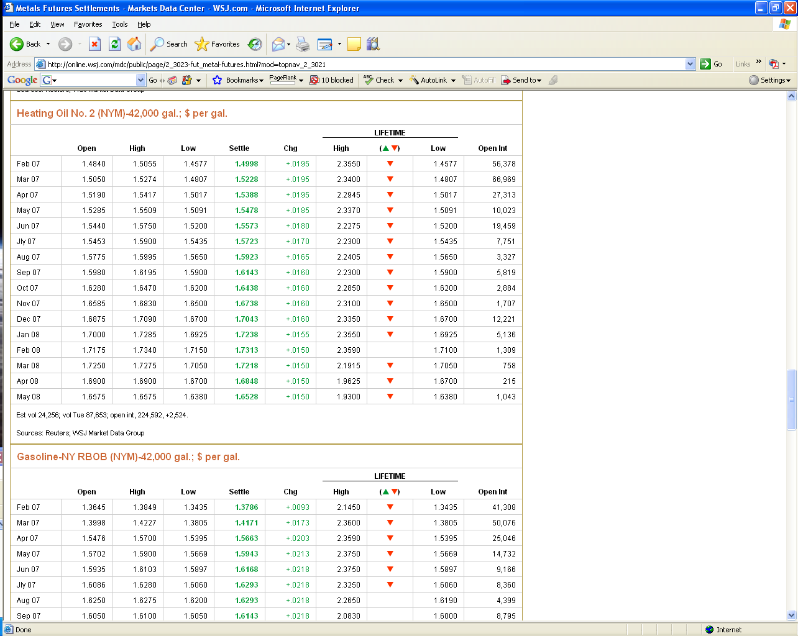

10. Currency Table
Reading down, it is how many units of that foreign currency you receive for 1 unit of the currency listed at the top of the column.
KEY CURRENCY CROSS RATES
9:31 a.m. EST 01/18/07Key Currency Cross Rates
 | Dollar | Euro | Pound | SFranc | Peso | Yen | CdnDlr
Canada | 1.1733 | 1.5183 | 2.3128 | 0.93894 | 0.10764 | 0.00967 | ...
Japan | 121.32 | 156.99 | 239.15 | 97.087 | 11.130 | ... | 103.40
Mexico | 10.901 | 14.105 | 21.487 | 8.7233 | ... | 0.08985 | 9.2905
Switzerland | 1.2496 | 1.6170 | 2.4632 | ... | 0.11464 | 0.01030 | 1.0650
U.K. | 0.50731 | 0.65645 | ... | 0.40597 | 0.04654 | 0.00418 | 0.43237
Euro | 0.77280 | ... | 1.5233 | 0.61844 | 0.07089 | 0.00637 | 0.65865
U.S. | ... | 1.2940 | 1.9712 | 0.80026 | 0.09174 | 0.00824 | 0.85230
Source: Reuters

11. How to read the Stock Ticker
The stock ticker is that scrolling numbered and lettered tape often found at the bottom of financial shows. For instance, you might see the following:
MSFT_{5k} @ 50.50 ⇓ 0.2
This means that the last trade of Microsoft was for 5,000 shares at $50.50, down $.20 from the previous trade. Abbreviations that you will see are
K = 1,000
M = 1,000,000
B = 1,000,000,000
Color codes are used as well.
Green: Stock is trading higher than recent close
Red: Stock is trading lower than recent close.
Blue or White: Stock is unchanged from most recent close.
Not every trade is put up on the ticker, factors such as volume, price change, activity, and how widely held the stock is determines whether the trade will be put up on the ticker.

12. Interest rates and yields
There are several types of interest rates and yields. The following gives the formulas for each type of yield.
Holding period yield-All investment income divided by the initial investment. No time frame is referred to.
Annual interest rate or annual yield- this is simply a given return expressed in an annual basis.
Examples:
1)To annualize a holding period
Annual return = (1+r)^{1/n} -1 where r = interest rate per holding period and n = length of holding period in years
For 6 months, n =.5, for 2 years: n = 2.
One must also note the difference between the nominal annual interest rate and the effective yield. Differences arise when the nominal rate is compounded more than once a year, or less than once a year.
Examples:
1)given a nominal annual interest rate r, compounded m times in a year, the effective annual interest rate is
Effective return = (1+r/m)^{m} - 1 i.e. a 10% nominal annual rate compounded quarterly is
(1+0.1/4)⁴ - 1 =10.38%.
2)given a nominal return calculated less that once a year
Effective annual return = (1+r)^{1/m} - 1, this is just like annualizing our holding period.
Taking this to the extremes, as m approaches infinity, the effective rate is r_{a}=e^{rc}-1 where r_{a} is the annual nominal rate and r_{c} is the continuously compounded rate. Conversely, a continuously compounded rate is equal to r_{c}=ln(1+r_{a})
Examples:
1)a 10% nominal annual yield is equal to ln(1+0.1)=9.53%
2)a 10% continuous rate is equal to e^{0.1} - 1=10.51%

The value e has its own economic interpretation. It is the value that $1 would accumulate to in a year if continuously compounded at 100%. Its approximate value is 2.718. To value any dollar amount continuously compounded is given as
V=Ae^{rt} where V is ending value of initial amount A invested at the continuous rate r. t is expressed in years i.e. for 6 months, t would be 0.5.
Example: $10 continuously compounded at 10% for 6 months has an ending value of 10e^{(0.1)(0.5)}=$10.512. If we also wanted the effective annual yield, note the 6 month nominal rate is 5.12% so the effective annual yield is (1+.0512)²=10.50%

After tax rates vs before tax rates
r_{AT}=r(1-t) the after tax return is equal to r multiplied by (1 minus the tax rate).
The equivalent taxable yield is ETY=r_{m}/(1-t) where r_{m} is the rate on the municipal. Note that this is an approximation for muni's selling at a discount since capital gains are taxable even for a municipal.
We now have covered several types of interest rates and returns accounting for both compounding and taxes. One final input to determine our true returns is to account for inflation.
The exact return while accounting for inflation is
r = [(1+R)/(1+I)] - 1 where r = real rate, R = nominal rate, and I = inflation rate.
For continuous compounding the formula simplifies to r=R-I

If we include taxes, the real after tax return is
r_{at}=[1+R(1-t)]/(1+I)] - 1

